c
MARITIME RESOURCE GUIDE
A Guide to Careers in the Maritime Industry
Ruth Sawyer | 5/15/15 | The Center for Wooden Boats

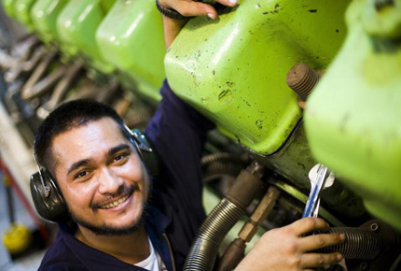
Introduction

Why Maritime?
In short, maritime jobs are anything that involves boats and the water. People drive tugboats, ferries, and fishing boats; fix, manufacture, design, and sell boats; install and refit electrical, refrigeration, and mechanical systems; load and unload cargo and passengers; and much more! There is a huge variety of well-paid jobs in the maritime field, and great prospects for employment all over the world. There are opportunities both on land and at sea, training programs that will pay their students to learn, and maritime academies that offer free tuition and guaranteed first jobs. There are jobs that require little to no training and experience – and jobs that require years of specialized training. It’s a great time to go into the maritime industry!
Here is a quick look at some of the advantages the field offers:
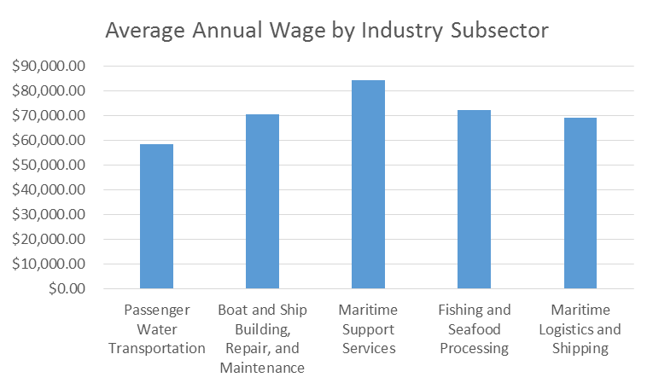
- Cool Jobs. There is something for just about anyone in maritime. Some jobs include lots of travel and the opportunity to see incredible things. Others might be closer to home but still include working with tight knit teams and the use of cutting edge technology. And while maritime careers at all levels can be hands- on, there is also a tremendous need for creative thinkers to meet the physical and political challenges of designing systems that work on the water.
- Great Pay. Maritime wages in general are generally higher than the state median wage of $51,000, averaging $70,800 per year. This pattern holds true for both entry-level jobs and those requiring high levels of education and training. In Washington, entry level sailors and marine oilers make a yearly average of $46,770, while wages for higher level positions both on and off the water are usually in the $70,000 to $90,000 range – and often much higher
- Advancement Options. Although some jobs in maritime require four-year college degrees or above, the industry offers a wide variety of jobs that require much shorter term training or education – and great opportunities to move up from within the ranks. Lateral career changes are also very common in maritime. Many workers who start in more hands-on or sea-based jobs early in their careers find that they can easily transfer that experience to land-based jobs in management, design, logistics, and more.
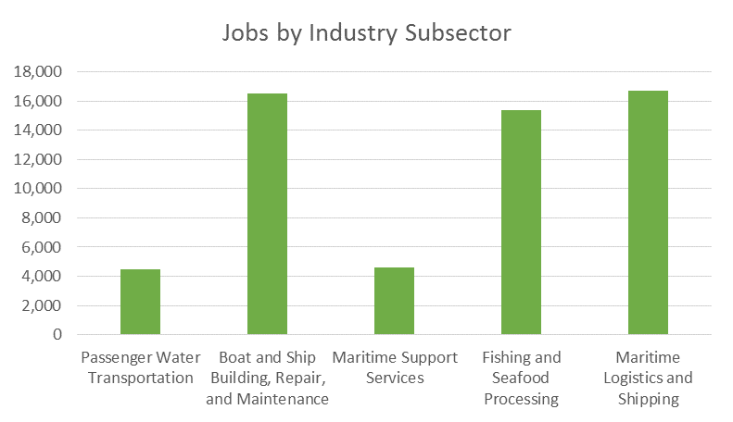
- A Growing Job Market. In the United States at large, maritime transportation occupations are the fastest growing category in the transportation occupations – and the industry is dominated by an aging workforce. The door is wide open for incoming workers with technical skills! In Washington, regional employment is projected to grow faster than the average for all occupations, and many of these openings are in well paid and stable areas.

How to Use This Guide
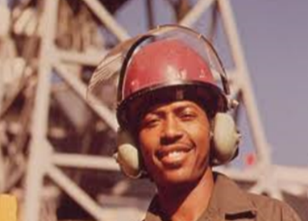
This guide is divided into several sections, depending primarily on what kinds of opportunities you are interested in. The first section, “Exploring the Maritime Industry” is designed to help you assess what kinds of jobs and programs are the best fit for you. It contains a couple of questions to help you think about your interests and a basic description of some of the major types of work throughout the industry. The second section is organized by type of opportunity. Whether you’d like to find a youth program that allows you to explore and learn maritime skills, a four-year maritime college, an entry level job, or anything in between – this section is designed to give you some ideas about your next step.

A Quick Look at the Maritime Sector
The maritime industry is composed of all the organizations that relate to the transportation of goods and people over major waterways – which is actually quite broad! To give you an idea of the breadth of maritime jobs, take a look at the list below. These are just the broad categories of work within the maritime industry!
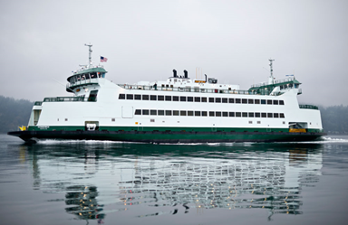
- Passenger Water Transportation, which includes state ferry operations, recreational tours, private ferries, and the private cruise industry;
- Ship and Boat Building, Maintenance, and Repair, which includes construction of commercial and recreational vessels, repair and overhaul, and maintenance;
- Maritime Logistics and Shipping, which includes Port and Harbor operations, their subcontractors, cold storage, and freight logistics firms;
- Fishing and Seafood Products, which includes commercial and recreational fishing, aquaculture, and processing and distribution of seafood;
- Maritime Support Services, which includes technical services like construction and environmental, parts and electronics suppliers, boat dealers, marinas, and professional services such as attorneys and accountants as well as NOAA and the Army Corps of Engineers; and
- Military and Federal Operations, which includes research, defense, and environmental mitigation activities of the Navy, the U.S. Coast Guard.

Maritime is a thriving industry with great pay, a growing job market, challenging work, and quick advancement for hard workers.

Exploring Maritime Careers
While there are many ways to divide and categorize the maritime industry, there are some broad divisions that make sense to consider as you begin to make decisions about your path. These divisions are categorized by function rather than sector – what you will be doing at work rather than what category it fits into. For this reason, we have divided this section into three broad categories: jobs that take place primarily on boats; trade, labor, and craft jobs; and technical and professional services jobs.
Not sure which category you might be most interested in? That’s okay! Take a look at the following questions for a bit more guidance. If you’re still not sure, it might be helpful to flip through the rest of the guide in order to learn more.
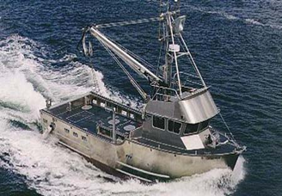
- Do you love being on the water and want to do it as your job? Your answer to this question will help you assess whether a career in vessel operations is a good fit for you. A strong interest in being on the water is definitely a perquisite for most seagoing jobs – skip them if you’re sure you don’t want that! And though most of the seriously on-the-water jobs are in vessel operations, there are some jobs in every category that have some degree of direct interaction with the water.
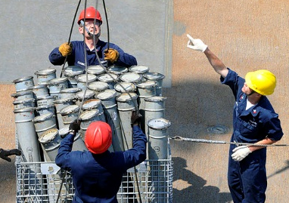
- Do you want to work primarily with your hands? Or would you prefer to work indoors, at a desk, or on a computer? Most jobs building and driving boats will require some degree of hands-on work, so steer clear of vessel operations or trade and labor jobs if you’re not at all interested in physical labor! Some of the jobs in the professional and technical services section may be the best fit instead. If you are interested in working with your hands, read on! Any of the categories we describe in this chapter can involve some degree of hands-on work – your choices revolve more around what kinds of work you want to do.
- Would you like to combine a non-maritime set of professional skills with a passion for the water? That’s great! If so, a professional or technical services job may be the best fit for you – although there is a great deal of crossover between trade, labor, and craft jobs as well. It just depends on what kinds of skills you are looking to combine with a maritime focus!

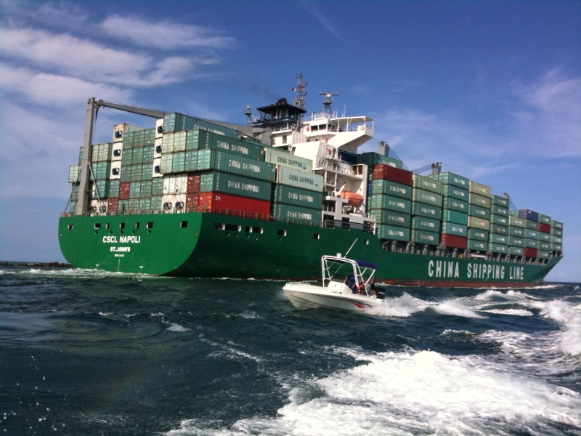
Vessel Operations Careers
Working at sea isn’t for everyone, but it can be a great choice for the right person.
Sea-based careers offer:
- Great pay and benefits
- Quick career advancement
- Daily increase of knowledge and skills
- Opportunity to work outdoors
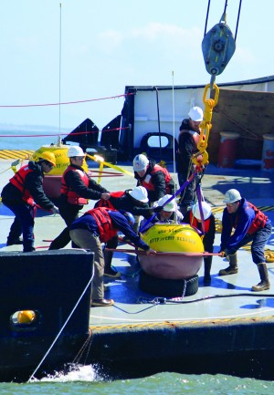
- A strong sense of teamwork and community
- Increased confidence and personal growth
- Travel and adventure
But there’s a tradeoff. As a mariner you may also experience:
- Homesickness
- Seasickness
- High-pressure work
- Long hours
- Close quarters
- Physical labor
So who is a good fit for vessel operations jobs? People who:
- Have a strong interest in going to sea, working outside, and working with their hands – though swimming ability is not needed!
- Have an ability to adapt to rapidly changing situations and are safety conscious
- Don’t have any recent DUIs on their record and can commit to being drug free
- Are going towards or already have a GED, high school diploma, or higher (most positions in the industry will require this)
- Are very persistent and hard-working!
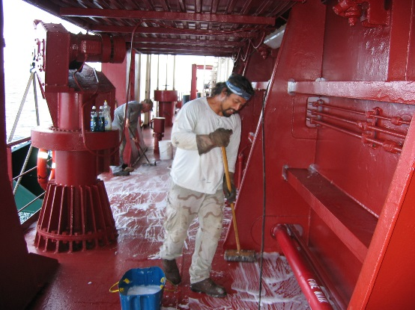
While perspectives and experiences differ, getting all of the information you can about your career of choice will increase your chance of job satisfaction immensely.
And remember: not all maritime careers take place onboard the vessels. There are plenty of land-based jobs in the technical and trades sections, below. You can also read interviews with employers, workers and other industry insiders to determine if the on-the-water life is for you.

Types of Jobs on Boats
There are essentially three different types of paths into a civilian career on the water.
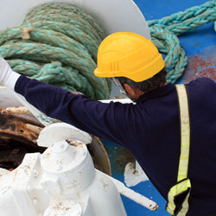
The first – and most formal path – is a job in the U.S. Merchant Marine. The vessels in this sector of the industry are privately-owned, U.S. registered merchant ships and a variety of towing, offshore supply, and passenger vessels. These vessels provide waterborne transportation for passengers and cargoes moving in domestic and international commerce – and the pathways for advancement are very well-defined by government regulations.
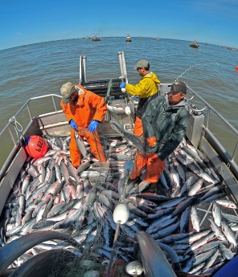
The second path is through the fishing industry. Fishing is a huge industry, with many of its own certifications, regulations, and culture. At higher levels of the industry, Coast Guard regulations govern the types of credentials that individuals must hold – so there is some overlap in the types of training and experience needed to advance in this industry. For the most part, however, fishing is very distinct from the other segments! Pathways into the industry and for advancement can therefore be quite variable and difficult to define.
Finally, a variety of other maritime professionals spend their lives on the water in smaller vessels – from sailing instructors to motorboat operators to the crew members on private boats. These professionals are regulated according to the particular industries they are a part of– so pathways to advancement can be extremely variable!

Careers in the U.S. Merchant Marine
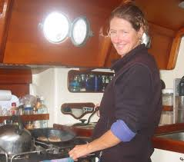
The three main departments of a workboat are the deck, the engine room, and the galley. On the deck, officers (like the captain and mates) lead the crew (sailors or deckhands) of the ship. In the engine room, engineers and others maintain all mechanical and electrical aspects of ship. In the galley – the kitchen – the chief steward and others care for the crew.
The chart below shows the major entry and higher-level positions in the deck and engineering departments of most seagoing vessels (positions in the stewards department are regulated a little bit different, so they are not listed):

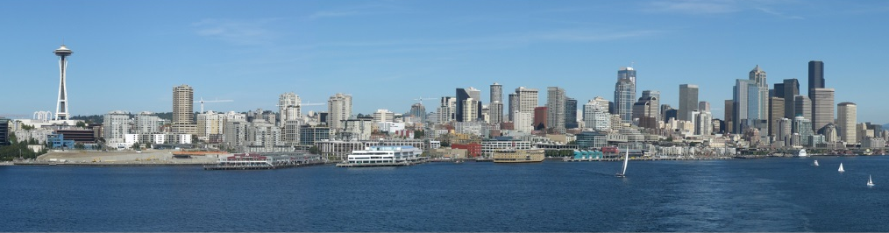
Careers in the U.S. Merchant Marine

Entry Level Positions

Rated Merchant Mariners

Officer Merchant Mariners

Merchant Mariner Job Descriptions
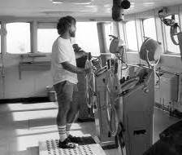
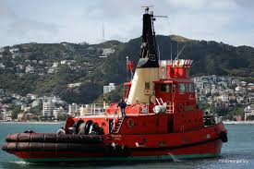
On the deck, sailors, or deckhands, operate and maintain the vessel and deck equipment. These individuals keep all parts of a ship – other than areas related to the engine and motor – in good working order. Entry level deckhands are called ordinary seamen and do the least-complicated tasks. They usually only need a couple of documents (discussed in more depth later) to qualify for work at sea. Experienced deckhands are called able seamen and usually make up most of a crew. Able seafarers have to be certified through the Coast Guard, proving their knowledge through testing and a certain number of hours of experience on the water. Some large ships have a boatswain, who is the chief of the deck crew; and a captain, or master, who is in charge over all. Sailors typically do the following:
- Stand watch and steer the ship, looking for other vessels or obstructions in their ship’s path, and for navigational aids, such as buoys and lighthouses
- Do routine maintenance, such as painting the deck and chipping away rust
- Keep the inside of the ship clean
- Handle lines when docking or departing
- Tie barges together when they are being towed
- Load and unload cargo
- Help passengers, when needed
On the engine side of vessel operations, ship engineers operate and maintain a vessel’s mechanical systems. This includes the engine, boilers, generators, pumps, and other machinery. Large vessels usually carry a chief engineer, who commands the engine room and its crew, and a first, second, and third assistant engineer. The assistant engineer oversees the engine and related machinery when the chief engineer is off duty. Small ships may only have one engineer. Engineers typically do the following:
- Maintain the electrical, refrigeration, and ventilation systems of a ship
- Start the engine and regulate the vessel’s speed, based on the captain’s orders
- Record information in an engineering log
- Keep an inventory of mechanical parts and supplies
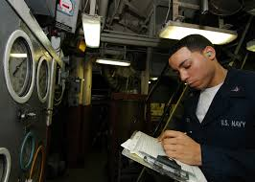
- Do routine maintenance checks throughout the day
- Calculate refueling requirements
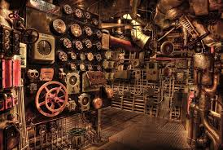
Marine oilers work in the engine room, helping the engineers keep the propulsion system in working order. They are the engine room equivalent of sailors. New oilers are usually called wipers, or pumpmen, on vessels handling liquid cargo. With experience, a wiper can become a Qualified Member of the Engine Department (QMED). Marine oilers typically do the following:
- Lubricate gears, shafts, bearings, and other parts of the engine or motor
- Read pressure and temperature gauges and record data
- Help engineers with repairs to machinery
- Connect hoses, operate pumps, and clean tanks
- May assist the deck crew with loading or unloading of cargo
Stewards serve in the galley and laundry facilities of a vessel, or on cruise ships. They are responsible for the preparation of food and caring for a vessel’s living quarters. New stewards are usually called cooks, and they sometimes have other duties in the deck or engineering department. The chief cook is the senior unlicensed crew member working in the steward's department. The chief steward is in charge of the department overall. Their duties typically include:
- Direct, instruct, and assign personnel to prepare and serve meals
- Maintain and clean officers' quarters and steward department areas
- Receive, issue, and inventory stores
- Plan menus
- Compile supply, overtime, and cost control records

Getting Started as a Merchant Mariner
Getting started and moving up in vessel operations can be very different from other industries. Sea-based jobs can be dangerous, and workers carry a lot of responsibility to do the job right. Because of this, many of the training requirements for sea-based positions are established by the U.S. Coast Guard – and many require extensive experience at sea. Fortunately, you have many options to learn the skills you’ll need!
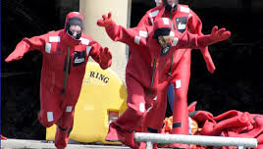
Depending on the type of career you’d like to have and where you want to be in the future, you can choose to:
- Receive on-the-job training, then earn the necessary licenses and certifications as you go
- Earn a two-year vocational degree
- Earn a four-year college degree
While the first option may seem simplest, more mariners are getting degrees than ever before because of the opportunities for advancement that they usually provide. From there, you'll move up based on experience, additional training or specializing, and hours logged out on the water.

Becoming a Sea Captain
One of the most well-known positions on a boat is that of captain, or master. This individual is in charge over all – and ultimately responsible for the safe operation of the vessel. For this reason, a captain must have U.S. Coast Guard licenses that document extensive experience and training. There are, however, multiple paths to the position! If you want to work as a Captain in the U.S. Merchant Marine (another name for privately-owned, U.S. registered vessels), there are three main approaches.
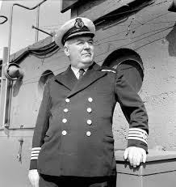
The traditional approach (or “Hawse pipe method,” which is named for the hole in the vessel that the anchor chain runs through) is to work your way up the ranks with on the job training. This takes more than a decade of hard work – but it is also more possible to actually advance in this way in maritime than in most other career fields. Sailors interested in a quicker path to the top can choose one of two other methods: Vocational School or a Maritime Academy. The Maritime Academy path is for those interested in receiving a bachelor’s degree along with their on-the-water education, while Vocational Training usually costs less money and offers either an associate’s degree, a certificate, or no college credit at all. Both offer an accelerated route to becoming a licensed Mate. From there, graduates must work their way up to master through additional sea time and testing.

Engineering Pathways
The pathways for Deck and Engineering are quite similar, in that both are governed by the US Coast Guard’s merchant mariner credentialing system. Both are categorized according to officer or rating endorsement to the merchant mariner document, and also by either national or International/STCW certifications.
To get into an engineering position on a vessel, there are several main entry points. These include:
- Direct employment by maritime vessel operators (which may or may not be through a union hall). These jobs are typically deck hand or wiper. Some employers offer Apprenticeships that can lead to an officer endorsement such as Mate or Assistant Engineer
- Enrollment in public training and education institutions. This could include getting a four year degree at MARAD-sponsored State Maritime Academy, which can lead directly to an officer endorsement – or attending a vocational college that offers training programs leading to officer or rating endorsements. These generally result in a certificate, associate’s degree, or bachelor degree
- Enrolment in private training institutions. Options include for profit or non-profit schools. Some are affiliated with labor unions
The US Coast Guard National Maritime Center administers the professional qualification process. You can find all you need to know at their web site, including a list of USCG-approved courses.
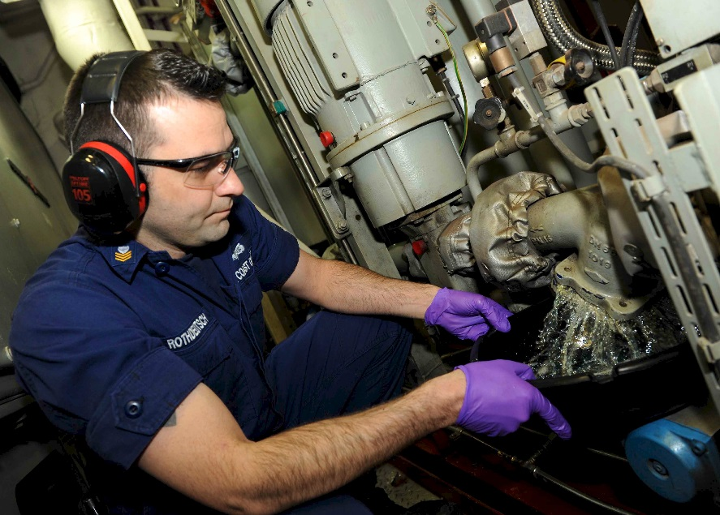
Advancement is earned through a combination of
- Documented sea service,
- Completion of USCG-approved Training programs
- Certified completion of established professional competencies, and
- Coast Guard examination
Sea Service is characterized by the size, horsepower, configuration, industry and operating location of the vessel.

Essential Maritime Credentials
To get almost any position on a seagoing vessel, you will need to apply for a Transportation Worker Identification Credential (TWIC) Card and a Merchant Mariner's Document (MMC). These credentials will allow you to apply for entry-level positions in the industry – or, if your experience is sufficient, to apply for higher-level positions and certifications as well.
The Transportation Workers Identification Credential (TWIC) and Merchant Mariners Credential (sometimes called the MMC, the MMD or the Z-card) are the first documents you will need to obtain if planning to work aboard a U.S.-flagged ship.
The two are similar and have many of the same requirements. The key difference is that the TWIC is administered by the Transportation Safety Administration, while the MMC is administered by the Coast Guard. You must get your TWIC before applying for the MMC. With these credentials, you can work on the deck, in the engine room or in the steward's department of a ship.
The MMC comes with various ratings depending on the type of work you want to do. Your rating changes as you advance your career. Some of the ratings establish the size of boat your experience and knowledge qualify you to work on; some establish what kinds of waters you can work in (inland, coastal, and open waters); and others list the positions you are qualified for (deckhand, mate, third engineer, etc.).
The MMC application will ask about your work history, your medical history and your criminal history. Your criminal history includes DUI's, sealed records, suspended licenses and more.
You will take a drug test and be fingerprinted and the Coast Guard will look at your driving record, too. Depending on which rating you're applying for, you may also take a physical and a written exam.

Additional Maritime Credentials
The MMC and the TWIC are not all it takes to work on a ship. Your company may require special training (perhaps including a separate physical exam and drug test), and specific sectors may also require specialized training.
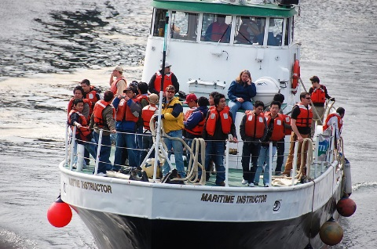
Of particular note are the credentials required for work on deep sea (ocean-going) vessels. The entry-level requirement for ocean-going vessels is Basic Safety Training (BST), which teaches personal survival techniques, fire prevention and firefighting, basic first aid, and personal safety and social responsibilities.
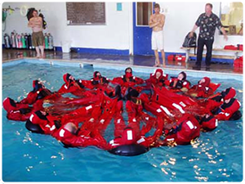
If you plan to work on a cruise ship, you'll also need to learn passenger assistance, crowd control, passenger safety and more.
The requirements for BST and many other trainings are established by the STCW (International Convention on Standards of Training, Certification and Watchkeeping for Seafarers). STCW trainings are available at many Coast Guard-approved schools, and the Coast Guard has many resources to help you figure out what trainings you might need.

Careers in the Fishing Industry
Washington’s commercial seafood industry is large and complex, encompassing fin fishing (which mostly takes place in Alaska but is largely based in Puget Sound), shellfish, and sport fishing. In addition to the traditional fishing jobs — captains, deck hands and the like — there are shipwrights and welders, pipefitters and engineers, specialists in engine/propulsion repair, experts in bilge cleaning, chandlers, insurance brokers, and the teams of people who manage and maintain the fishing ports. For clarity, this section focuses on the purely boat-based jobs. Management, science, and vessel design and repair can be found in the other sections of this guide!

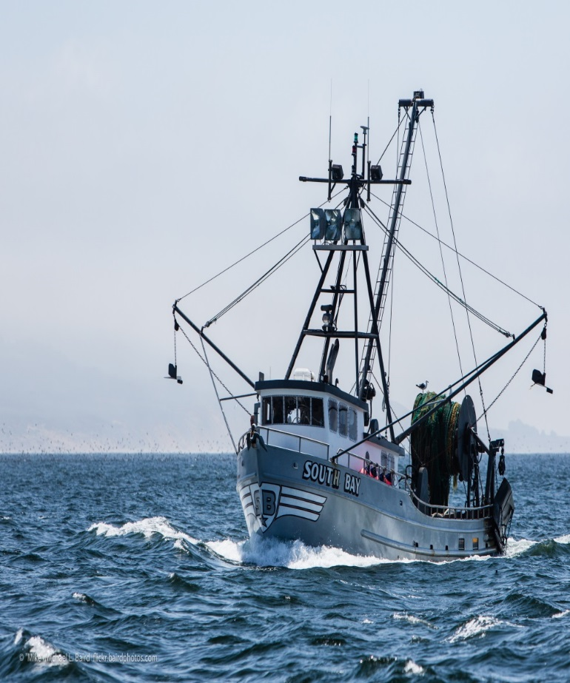
Fin Fishing Jobs
The seafood industry in Alaska has two related, but very different sectors: commercial harvesting jobs and seafood processing jobs. Essentially, harvesting is the act of catching the fish, while processing is the method by which the fish are cleaned, gutted and frozen. Since they are such different processes, fishing and processing are usually accomplished independently of each other.
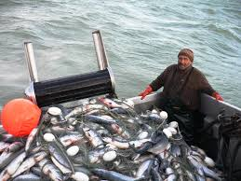
Processing can take place on floating processing plants, (boats that are also processors) as well as in offshore processing plants, and it is perhaps the easiest sector of the industry for new people to be hired. Processors deal directly with the fish through a large number of different jobs; including cleaners, slimers, office workers, deck crew or clean-up crews. Many workers find that a season as a processor opens opportunities in more interesting and higher paying jobs since established yourself in the industry and have gained important contacts. These more specialized and higher paying jobs are often on the harvesting end, and can be difficult to obtain during a first season in Alaska.
Commercial seafood harvesters – otherwise known as commercial fishermen – hold state and/or federal commercial fishing permits, quota shares, and crew licenses – and are engaged in commercial fishing for their livelihood seasonally or year-round. The different types of harvesting jobs depend on the type of boat a harvester works on. There are jobs on individual boats and jobs on large processing and catching boats. The smaller, individual boats don’t do any processing onboard and vary greatly in terms of how the ship is run as well as the jobs onboard. The larger vessels often catch and process fish on the same boat.
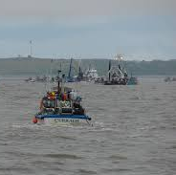
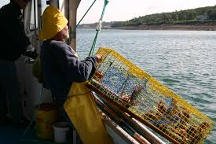
During harvest seasons, prospective crew members must walk the fishing docks to follow up each word of mouth lead to speak with the skipper personally. The travel and waiting for such an opportunity can be costly, both physically and monetarily. Crew members rarely leave good jobs, so only a small percentage of hopefuls find their berth in this manner. Most Near-Shore vessels are independently owned and operated. Obtaining employment on them is difficult. Replacement crew members are often family or are obtained through an industry association. Crew members are hired well before the season begins. To get jobs on larger factory trawlers, most people start as processors and move up from within.
- Most companies look for seafood employees who:
- Will work the full season or contract period
- Enjoy physical work
- Enjoy working as a team in a multicultural environment
- Take pride in their work to make a quality seafood product
- Work with others in remote, adventurous locations under invigorating conditions wearing
rain gear and rubber boots
- Recognize the value of following directions and safety rules
Alaska’s Seafood Industry has many opportunities for seasonal or full time work. Advancement into management or technical positions with good pay and benefits is possible.

What Kinds of Boats Could I Work On?
  - Vessel Operations Sectors

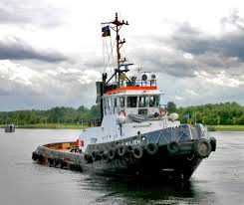
Shipping & Transportation
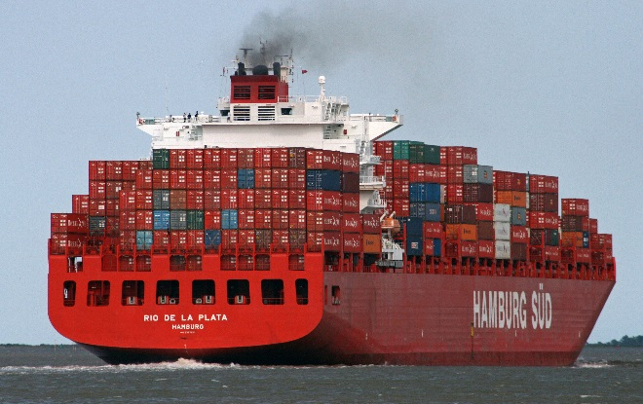
Container ships, cargo workboats, tankers, supply vessels, etc.

Commercial Fishing
Some of the most challenging and dangerous work in the industry

Cruises & Ferries
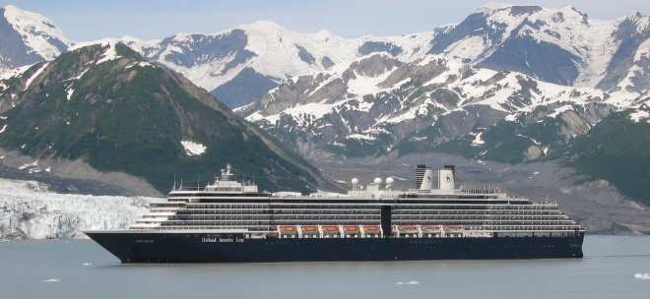
Includes small and large ship cruises plus the Washington State Ferry system – the largest in the US

Science and Research
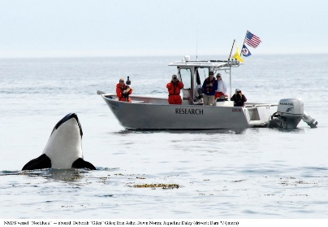
Scientific organizations like NOAA study weather and other ecological patterns, including the effects of fishing and other human activity

Offshore Operations
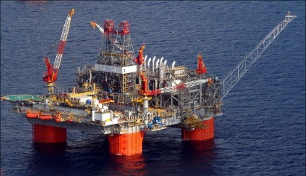
Includes any work done at sea on platforms—most notably, drilling for oil. The platforms are similar to land-based factories, except that ships are used alongside for various tasks – like laying cables, bringing in supplies, and cleaning up spills

Recreational Boating
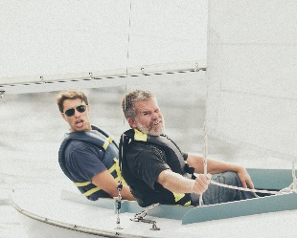
Includes sail instructors, recreational fishing and small tour boats, and hired crews on private yachts

Government Operations
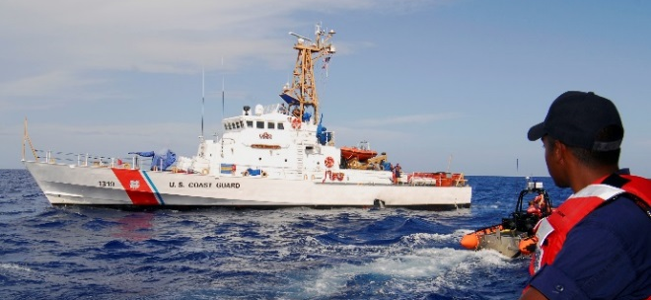
Includes the U.S. Navy, port police, rescue services, military sealift command, and the U.S. Coast Guard, which enforces maritime law and assists in emergencies

Careers in the Skilled Trades
There is an incredible diversity of hands-on, land-based careers in the maritime industry – everything from manufacturing boats to installing speaker systems and unloading cargo. There are two main segments of the industry:
- Vessel Fabrication, Maintenance, Refurbishment, and Repair (This area of the industry includes the construction of new commercial and recreational vessels plus the refurbishment, refit, maintenance, and repair of older ones. It ranges from canoes to yachts to the ships used for fishing and shipping – and everything in between. This sector also includes the production of prefabricated ship and barge sections or offshore platforms for oil and gas well drilling, and may involve manufacturing and other facilities outside of boatyards.)
- Port Operations (Port activities include cargo and passenger loading; unloading and distribution; construction of docks and other water-based facilities; spill cleanup; and more)
Many jobs in these segments have significant overlap with each other or with other manufacturing, transportation, and construction jobs, so the skills needed for maritime jobs are often useful in other industries as well!

Careers in Vessel Fabrication and Repair
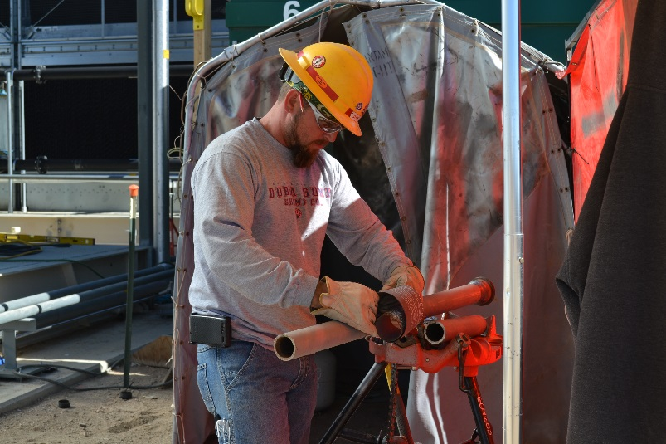
Highly-skilled, well-paid vessel fabrication and repair jobs can be found all around the waterways of Washington. Many of these jobs are in larger shipyards simply because these projects can employ hundreds of people at a time – but there are also a substantial number of excellent jobs in the state’s smaller boatyards.
In large shipyards, each individual generally specializes in a particular type of trade that is tied to a union. In this structure, any given individual may have certain skills (like welding or rigging), but only use them in the context of their trade’s role in a larger project. By contrast, job opportunities at smaller, non-union yards tend to be dictated more directly by an individual’s skills and the needs of the yard. This means that the categories described below reflect shipyard job titles most accurately – but that the skills listed for each position might be the job titles at a smaller operation.

Types of Shipbuilding Jobs
In a shipyard, boilermakers put together a boat’s hull and superstructures. They are skilled in welding, fitting large parts together, and rigging (moving heavy things safely through tight spaces). They are assisted by operating engineers, who operate cranes and other heavy equipment. (A subset of the operating engineers – the stationary engineers – also operates boilers).
Once the main structure of a ship is built, skilled craftspeople do a variety of finish work to mak e sure all of the ship’s systems are installed correctly. Sheet metal workers make sure that all parts of the ship are properly ventilated by installing sheet metal and duct work. Pipefitters install the piping systems, while electricians install and upgrade the ship’s electrical systems – including audiovisual and smart ship technologies. Finally, painters and upholsterers finish the surfaces of both internal and external components with the appropriate colors and types of paint or fabric.
All of these workers are supported by a variety of other skilled laborers. In addition to doing any of the wood work required for a boat, carpenters also build all of the staging that allows people to move freely throughout the job site. Machinists work both on and offsite to manufacture and install metal parts – they are often assisted by drivers and warehousemen, who deliver parts to the job site. Finally, laborers help with general cleanup and do some tasks like sandblasting.

Careers in Port Operations
There is a ton of work to be done at both cargo and passenger ports around the country. (In fact, Washington State has five of the top 50 ports by total trade)
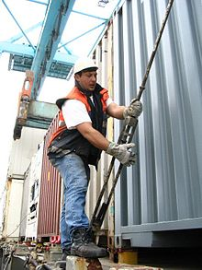
When a ship arrives at a cargo port, coordinated sets of workers unload, store, unpack, and reload the ship’s containers. The jobs involved include the crane operators, the workers who connect the containers to the ship and each other, the truck drivers that transport the containers from the dock and storage area, the workers who track the containers in the storage area as they are loaded and unloaded, as well as various supervisors. Those workers at the port who handle and move the containers are likely to be considered stevedores or longshoremen.

Getting Started in the Skilled Trades
There are many paths to a career in maritime trade, craft, and labor occupations, and your path depends in large part on where you want to end up! You can start from:
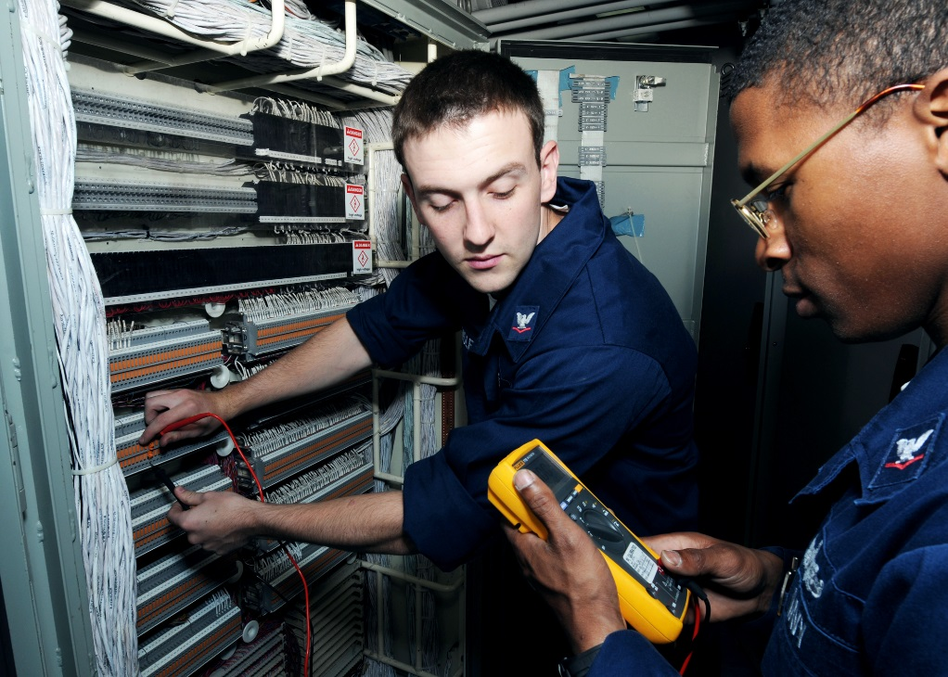
- An entry-level job
- An apprenticeship
- An educational program, like those offered at community colleges
- Skills you already have, like as an electrician or IT specialist
From there you’ll move up based on experience, additional training, and specializing. As a rule, however, apprenticeship is generally a path to union-based work in larger shipyards; while educational programs and working your way up are more realistic for work at smaller yards.

Getting Started in a Non-Union Career
Many smaller boatyards are looking for employees with a range of skills – including those at the entry level. Some will take on unskilled helpers and train them for the positions that are needed; others hire graduates of community college programs that teach compatible skills. Hiring structures are less formal than at larger shipyards – and as such there is also more room for advancement or lateral movement within a company.

Getting Started in a Union-Affiliated Trade
Most of the largest shipyards and ports contract directly with unions to hire workers – including the ones that are officially non-union employers! As such, usually the best way to learn a craft is through union-sponsored training, often in the form of apprenticeships. (Some community college programs are also union supported). The vast majority of workers enter the trades in this fashion – though it is also possible to work your way up without an official apprenticeship period.

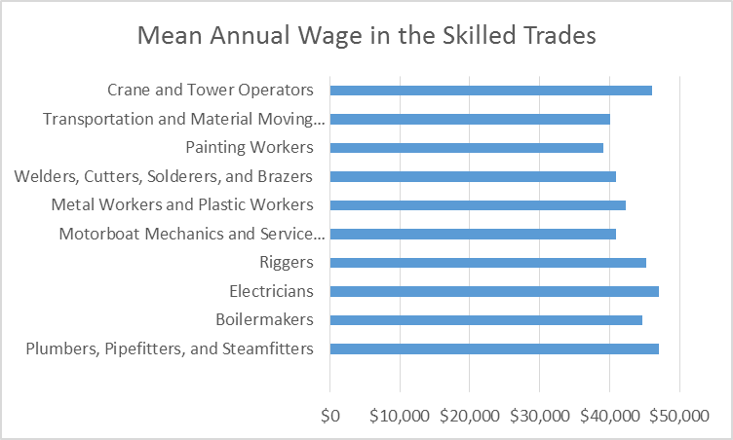
What is an Apprenticeship?
Apprenticeships are essentially a formalized period of paid training. They combine paid on-the-job training with related classroom instruction – meaning that completing an apprenticeship program fully certifies the worker at the journey level. New apprentices generally start at 70% of a journeyman’s wage, earning a pension and full benefits along with their paycheck. Their wages are increased periodically over the course of three years, and each week usually involves 40 hours of paid work along with 3 or so extra hours of schooling. (Machinists do things slightly differently, with one paid day of school every two weeks).

How do I get into an apprenticeship program?
Each apprenticeship has a slightly different application process, depending on the union that administers it. I n general, most include several components: a visit to the union office to fill out a paper application, an interview, and some basic screening tests. Some unions only hold interviews when they are actively trying to fill positions; others hold interviews on a rolling basis and pull successful applicants from a list when they are needed.
Since the process is different for each apprenticeship, the best way to find out up-to-date apprenticeship information is to call the union you are interested in working for. If you’re interested in more general information, the Department Labor and Industries also maintains a list of apprenticeships on its website.

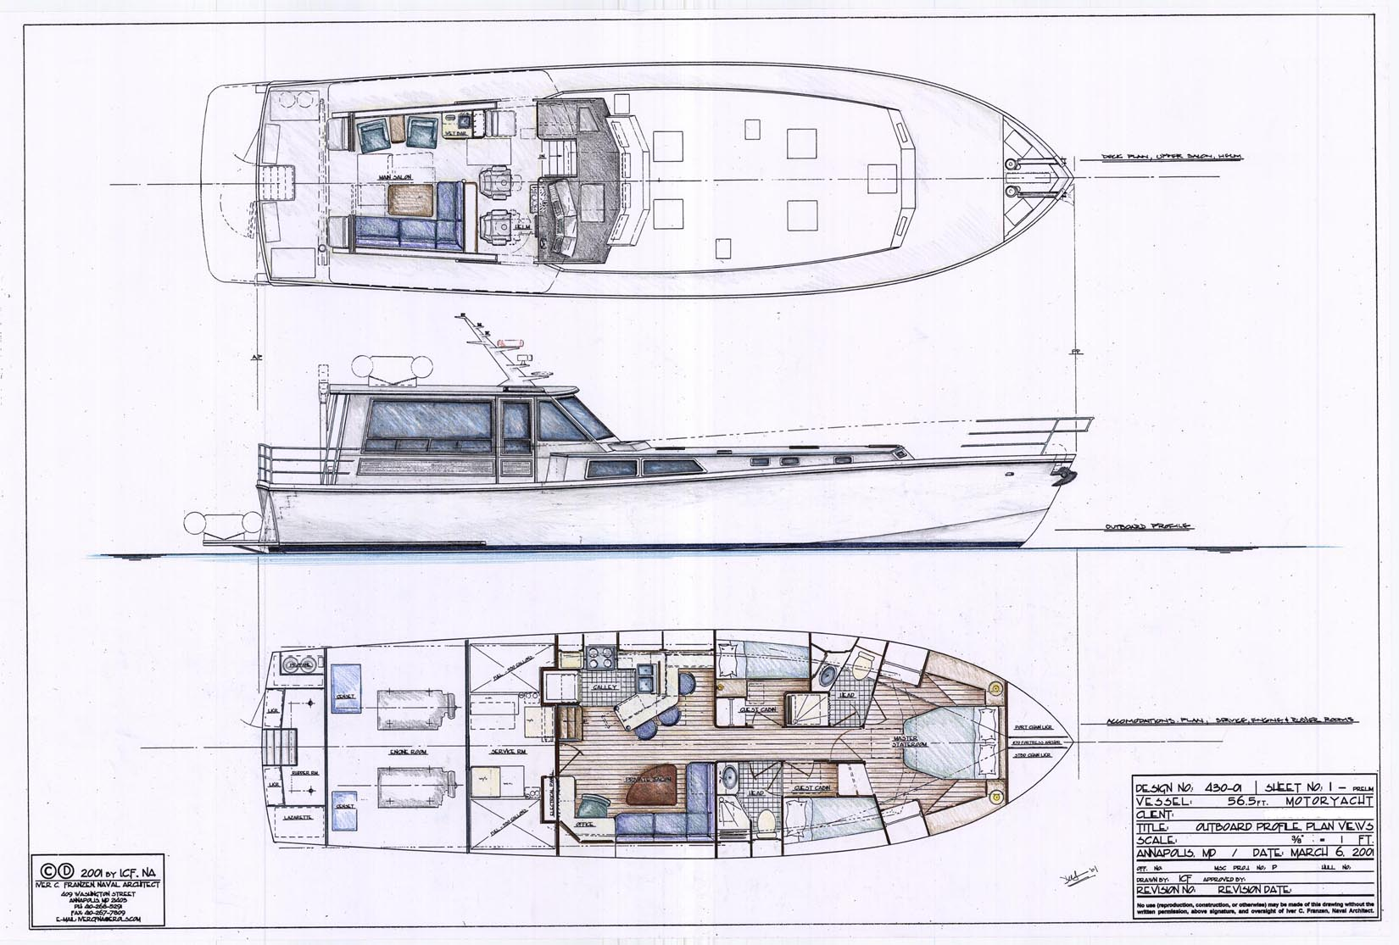
Professional and Technical Services Careers
The maritime industry is not just about ships and cargo – it is also about people and services. For every one seafarer licensed to work on a boat, nine professionals coordinate, supervise, and manage shipping operations from shore. These individuals work for businesses that take care of logistics, supply chain management, and all the administrative needs of maritime companies. In other sectors of the industry, professionals design and supervise construction and repair work; sell, rent, and insure boats; and do tons of other behind the scenes work to keep boats on the water and customers happy.
Almost any job that you can imagine can be a part of the maritime sector – everything from documentary filmmakers to accountants. There is such a wide variety of positions that this guide will only delve into professions that require the majority of training to be specific to the maritime industry. Positions that require extensive training in other fields - like accounting, law, human resources, information technology, and others - are detailed in many other resources. If you're interested in looking more deeply at these positions, we recommend starting with a quick internet search!

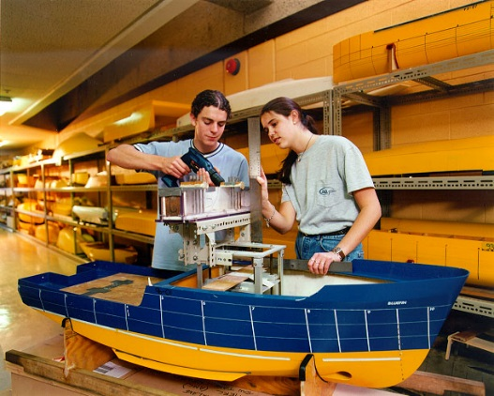
A Quick Overview of Professional Services Careers in Maritime
There are three main sectors of the maritime professional world: Logistics and Administration, Vessel Design and Construction, and Research and Management. For the most part, each requires some degree of specialized college-level training – though there are exceptions – and there is some degree of overlap between each segment.

Careers in Maritime Logistics and Administration
Every sector of the maritime industry requires some degree of investment in logistical and administrative matters. Cargo ports have perhaps the most complex logistical ecosystem – though there are also professional logisticians in every other sector. Also of note in this category are all of the professionals who
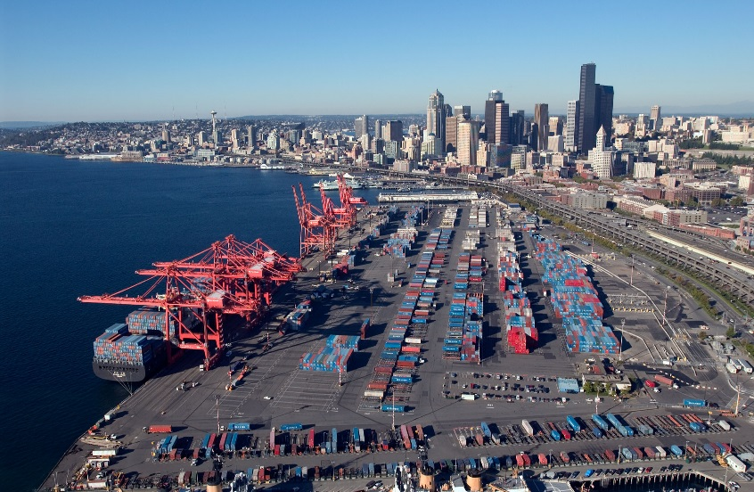
At a cargo port (like the Port of Seattle), specialists are need to make sure that shipments and people keep moving in and out of the port efficiently. These individuals analyze and coordinate an organization’s supply chain—the system that moves a product from supplier to consumer. They manage the entire life cycle of a product, which includes how a product is acquired, distributed, allocated, and delivered.
As soon as a vessel enters port, agents arrange for pilot services and towing, medical and dental care of the crew, and ship supplies. They coordinate with pilots, towing firms, chandlers (who supply the vessels with food, clothing, nautical equipment, and other necessities), bunkering firms (who provide fuel to the vessels), marine surveyors (who inspect the vessels and cargo), and marine construction firms.
Once the ship is in port, stevedoring firms manage the longshoremen and cargo-handling activities; while terminal operators operate the areas where cargo is loaded and unloaded. Containers that have been offloaded are managed by warehouse operators, who coordinate their storage and consolidate units into shipping lots. Meanwhile, freight forwarders and customhouse brokers arrange for containers to be delivered between a port and inland destinations.

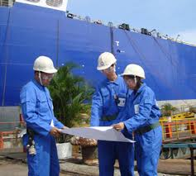
Ship Design and Construction Careers
The design and construction of boats and offshore platforms is an incredibly dynamic industry. Marine structures, vessels and ocean systems are unique because only a small number of each design is built, they are often very large and complex, and they operate in a uniquely demanding environment. For these reasons, the industry seeks strong spatial thinkers that can creatively approach problems!
People who design ships professionally are usually trained as naval architects or marine engineers. In general, naval architects design the frame or structure of a boat – including the form and stability of the boat’s hulls. Marine engineers, by contrast, are concerned with the ship’s mechanical systems. They ensure that a ship’s engine, electrical systems, refrigeration, lighting, and controls are designed so that they will function optimally. Ocean engineers use a related but different set of skills. They develop some of the instruments and systems used by ocean-going vessels – including creating underwater robots, buoys for data collection, and more!
On the construction side of the industry, skilled professionals are needed to make sure designs get translated effectively into the physical reality of a finished product. This is an essential part of the ship-building process, and can make or break a project’s cost and overall success. To do this work, construction managers make sure the appropriate people and tools are brought together at the work site. They manage construction logistics, hire contractors or subcontractors, and work with designers and shipyard workers to get things done.

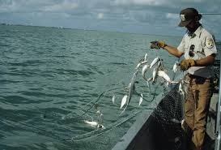
Research, Enhancement, and Management Careers
These high-level careers generally have two very different pathways. First is a more policy-focused management path – with jobs at various ports, government agencies, and consulting groups. Second, many individuals take a science-focused path; with jobs researching, managing fisheries, and other related tasks.

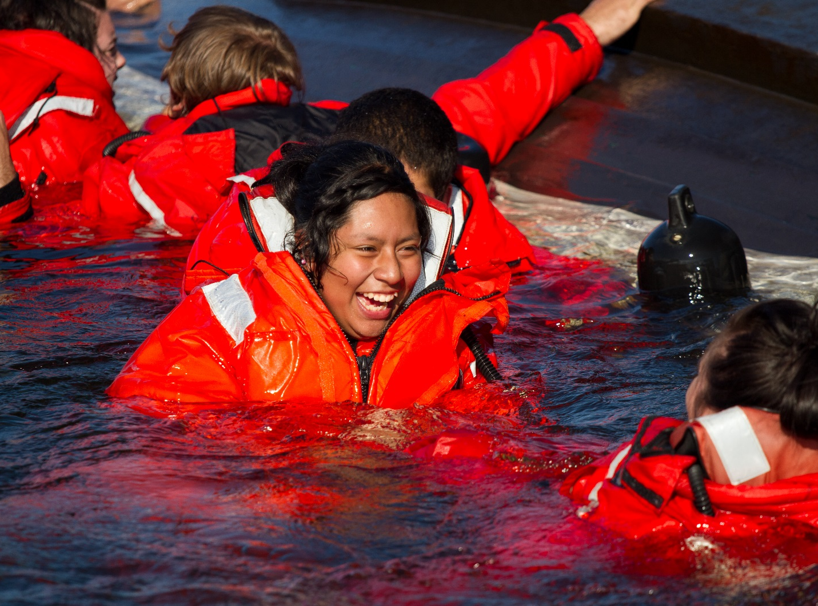
Maritime Opportunities for Young People
There are a variety of in-school, out-of-school, and pre-apprenticeship programs that are a good fit for young people who are not quite old enough for college or full-time work. Some of these programs allow students to explore maritime careers through specialized programs that offer high school credit; others are pre-apprenticeship programs that run during after-school hours. In addition to the offerings listed here, efforts are underway to reinvigorate career and technical education in the state – many more may be available soon! In this section, you can find more information on:

Out of School Programs:
- The Center for Wooden Boats’ Job Skills Training Program (Seattle)
- Sea Scouts (Seattle, Bellevue, Port Townsend, and Port Orchard)
- The Community Boat Building Project (Port Townsend)
- Tacoma Community Boat Builders (Pierce County)

In-School Programs:
- Ballard Maritime Academy (Seattle)
- Marine Science and Technology Program at the Puget Sound Skills Center (Seattle)
- Ocean Research College Academy (ORCA)
- Home Port Learning Center (Bellingham)
- Career Workplace Exploration in Skilled Trades (Seattle)
- Apprenticeship and Construction Exploration (ACE)

Program Descriptions: Out of School Programs

1. The Center for Wooden Boats Job Skills Training Program (Seattle)
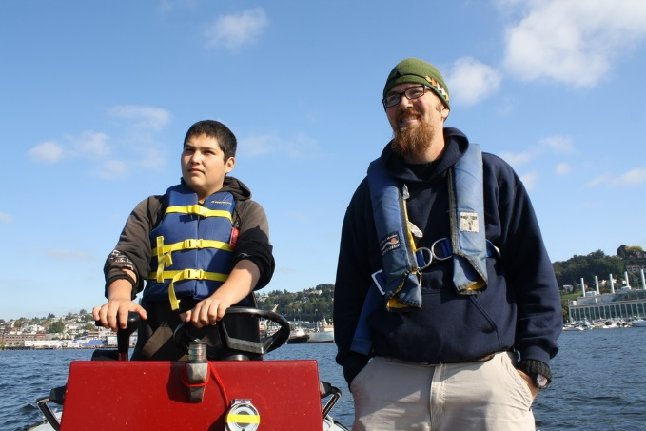
The Job Skills Program is designed to help young people build employment skills for a variety of careers – with a special focus on the maritime trades. Students will explore various skills and career pathways through field trips, guest speakers, and hands-on experience on the water and building boats. The program is designed around the school calendar, and offers a weekly stipend.
Minimum Qualifications:
- 16-20 years of age
- Working towards a GED or High School Diploma
- From a low-income and/or underserved background
- Legal to work in the US
More Information / To Apply: Contact Tyson Trudel at ttrudel@cwb.org or visit http://cwb.org/classes/job-skills-training/.

2. Sea Scouts (Seattle, Bellevue, Port Townsend, and Port Orchard)
Local Sea Scouts programs are run through the Boy Scouts of America’s Venturing Program (which is a co-ed program), and aim to introduce young people (ages 14-21) to maritime tradition. Local Sea Scout programs in the Chief Seattle Council center around getting on the water, and are an excellent fit for young people who want to learn leadership as well as nautical skills.
More Information / To Apply: More information and contacts for each local program are listed at http://www.seattlebsa.org/Main-Website-Content/Sea-Scouts
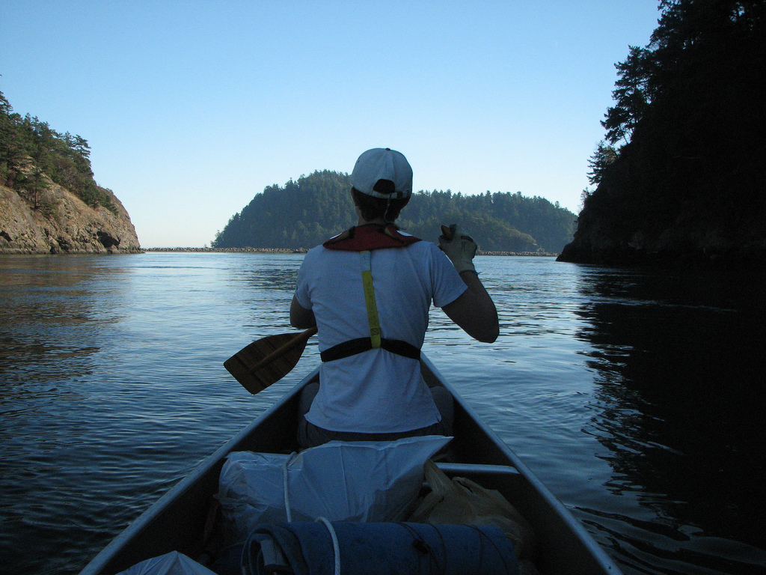

3. Community Boat Building Project (Port Townsend)
The Community Boat Project has two high school programs (Boat Building and Puget Sound Voyaging) and one for middle school students (Sailor Science). Each program emphasizes hands-on maritime skills, and is offered in collaboration with local school programs.
More Information: Visit https://communityboats.wordpress.com/programs/

4. Tacoma Community Boat Builders (Tacoma)
Tacoma Community Boat Builders builds and sails wooden boats with at-risk youth from South Puget Sound. The program is an apprenticeship based program with participants and mentors working together building wooden boats using applied learning, work skills development, team work, and the appreciation of fine craftsmanship. Currently, youth are referred to the program through the Pierce County court system, but TCBB plans on expanding its offerings to include a range of adult and family-oriented programs.
More Information: http://www.tacomaboatbuilders.org/

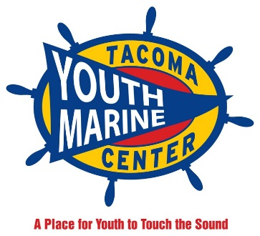
5. Tacoma Youth Maritime Center (Tacoma)
Tacoma Youth Maritime Center seeks to teach young people how to be good boaters, good mechanics, and good citizens. Programs include intensive navigation, safe boating, small engine repair, diesel mechanics, fiberglass repair and other related maritime skills.
More Information: http://www.youthmarinefoundation.org/

Program Descriptions: School Programs

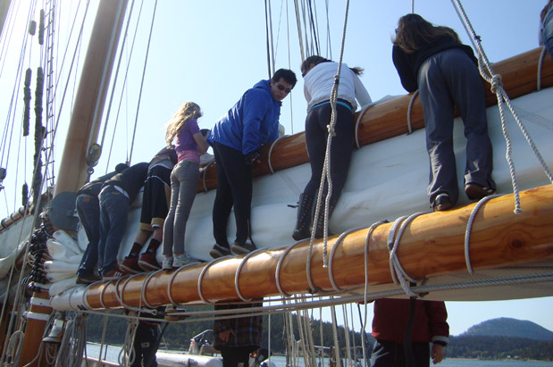
1. Ballard Maritime Academy (Seattle)
Ballard Maritime Academy is a program for Ballard High School students, including oceanography and practical hands-on trips.
More Information / To Apply: Contact John Foster at (206) 252-1137 or jffoster@seattleschools.org for more information.

2. Marine Science and Technology Program at the Puget Sound Skills Center (Seattle)
The Marine Science and Technology Program at the Puget Sound Skills Center is part of the Highline Public Schools system. Students attend the PSSC for half of the day and their home school for the other half.
Minimum Qualifications:
- Must be a high school junior or senior on a graduation track
- Students must be from King County but may have to provide their own transportation if they are not from the Highline, Federal Way, Tahoma, or Tukwila school districts
More Information: Visit http://www.highlineschools.org/pssc or Contact Joe Weiss at psscmarinelab@gmail.com or (206) 433-2107

3. Ocean Research College Academy (Everett)
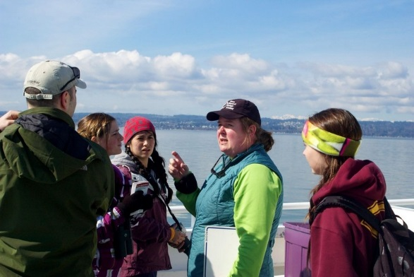
The Ocean Research College Academy (ORCA is an early college high school academy that bases its entire curriculum on the local marine environment. ORCA uses a Running Start framework (in partnership with Everett Community College to offer its students both high school and college credit. The program is open to public high school juniors and seniors.
More Information / To Apply: http://www.everettcc.edu/programs/math-science/orca/

4. Home Port Learning Center (Bellingham)
Home Port Learning Center is a transitional education program for at-risk youth in Whatcom County. Students in the program engage in maritime, vocational, and academic curriculum during school hours.
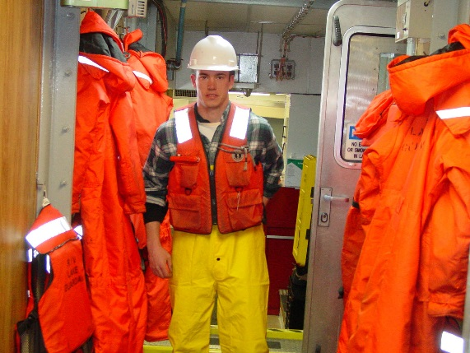
Minimum Qualifications:
- Enrolled in the Whatcom School District
- Students must be drug free (they will be randomly tested)
More Information / To Apply: Contact homeportlc@gmail.com or go to www.homeportlc.com

4. Career Workplace Exploration in Skilled Trades (Seattle)
Career Workplace Exploration in Skilled Trades (CWEST) is open to any 16-or-older Seattle Public Schools high school student. It is intended for students who want to find out about careers in the skilled trades like carpentry, electrician, plumbing, welding, concrete, etc. To get this kind of experience, the students work two days a week for 3 hours on an actual jobsite in a one-to-one relationship with a journeyman mentor. (One of the jobsites is the Marine Maintenance Department at the Port of Seattle!) In the other three days, they work in the classroom and shop at Rainier Beach High School.
More Information / To Apply: Visit http://www.seattleschools.org/modules/cms/pages.phtml?sessionid=&pageid=220319 or contact Kevin Grayum at kmgrayum@seattleschools.org

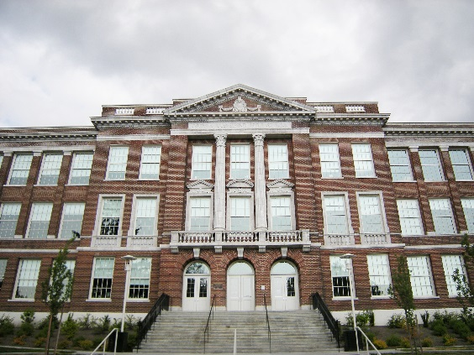
5. Apprenticeship and Construction Exploration (Seattle)
The Apprenticeship and Construction Exploration (ACE) is a school-to-work program based out of Cleveland and Franklin High Schools. Students attend a class at South Seattle Community College and the apprenticeship training centers for half a day, five days a week. For more information, contact (206) 605-7043.

4. Seattle Skills Center Classes (Seattle)
The Seattle Skills Center currently offers classes in Maritime Science and Technology at Ballard High School, but plans are in the works to expand its offerings! The Seattle Skills Centers offer career and technical education for young people in the Seattle area, and offer some maritime certifications as well as a chance to explore the industry.
More Information / To Apply: Visit http://skillscenter.seattleschools.org/

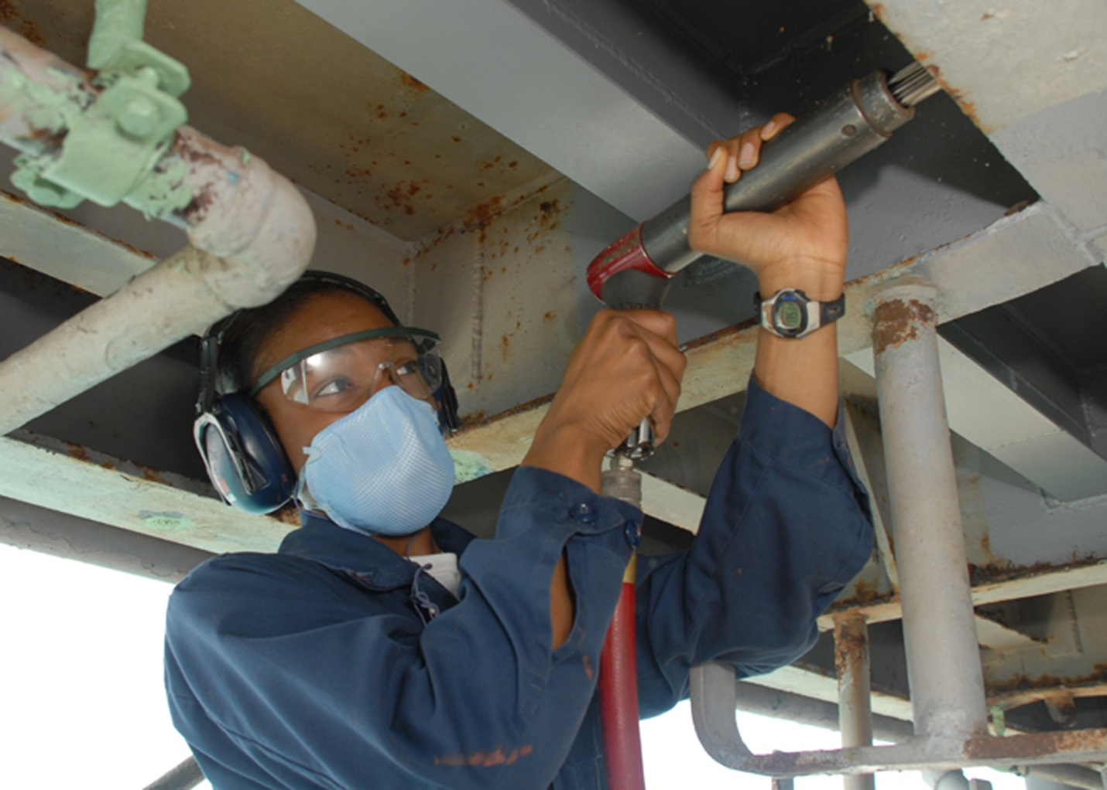
Entry-Level Seasonal Positions
As a rule, the jobs in this section don’t require much (if any) previous work experience, won’t make you get any maritime licenses, and don’t require a college education – though they do often require applicants to be over 18 years of age. Many offer good prospects for advancement and a good way to save money relatively quickly – as well as a chance to see if pursuing a maritime career could be a good fit. Here’s a quick overview of the jobs in this section:

Seasonal Positions in Seattle:
- Argosy Cruises (1) – These jobs are seasonal (with both summer and winter seasons), customer-service oriented jobs that offer low barriers and an opportunity to advance in both the maritime and hospitality industries – especially if the applicant is over 21 years of age. Pay is $10-$12 per hour.
- Holland America (2) – Offers seasonal customer-service jobs from April to September.
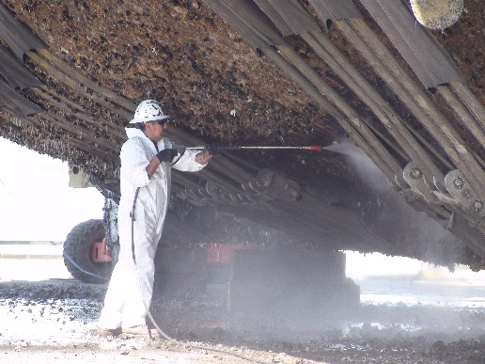
- Small Boat Yards – There are hundreds of jobs in the Seattle area that don’t hire through big HR companies and offer excel lent experiences for first-time workers. They are harder to find, though! Reach out to your local maritime resource people for more information!
- Helper Positions at VIGOR Industrial – Occasionally VIGOR posts entry-level “helper” positions on their website. Interested? Look at www.vigorindustrial.com/jobs for current listings.

Seasonal Positions in Alaska:
Fish Processing Jobs are generally available from early spring to early fall, and are an excellent opportunity for almost anyone who is willing to live in Alaska and work extremely hard. They do not require applicants to have any work history or ability to read English. Companies that hire seasonal fish processors include:

- Trident Seafoods (3), US Seafoods, Icicle Seafoods, Peter Pan, and many more! Application procedures are not detailed for each company, but all are very similar to the process detailed under the entry for Trident Seafoods.
- Gillnets in Bristol Bay (4) have a slightly different hiring process because they are generally smaller, family-owned operations, so there is a separate listing for this entry.

Job Descriptions: Seattle-Based Jobs

1. Argosy Cruises in Seattle, WA
These jobs are seasonal, customer-service oriented jobs that offer low barriers and an opportunity to advance in both the maritime and hospitality industries – especially if the applicant is over 21 years of age. Pay is $10-$12 per hour.
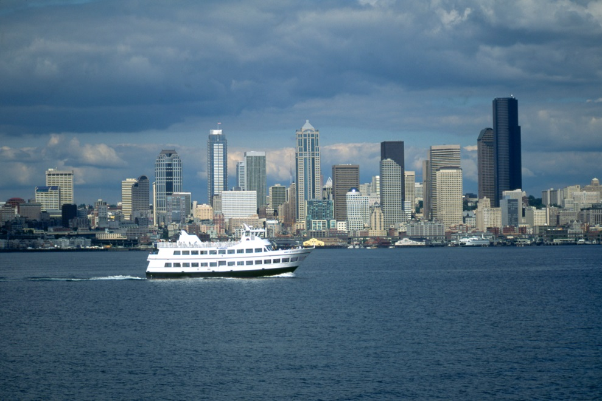
Minimum Qualifications:
- Must be over 18, but over 21 is preferred as the boats serve alcohol
- Able to pass a drug test
- Legal right to work in the United States
Other Information:
- Argosy “hires the smile, then trains the skills” – which means that applicants with a positive demeanor but few skills will do very well in the hiring process.
- Summer season is the busiest, followed by December. Argosy hires year-round.
- A background check is part of the application process, as some employees will have direct contact with children and the elderly. Concerns include child abuse and/or sex-related crimes.
Advantages: Excellent opportunities to gain sea time and advance in the hospitality industry – many employees go on to work at Victoria Clipper or the Washington State Ferry system. Boats are based mainly in Seattle, but there are also lines running out of Kirkland, Everett, and the South Sound.
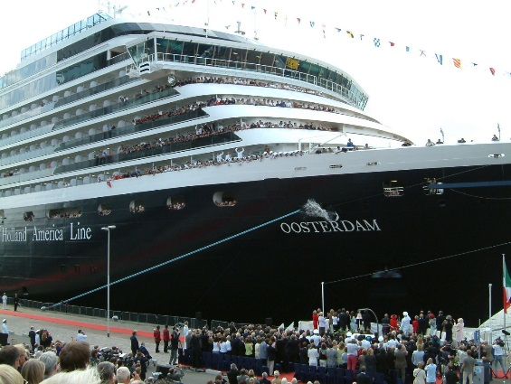
To Apply: Send a resume and short cover letter stating your qualifications and your available start date to: jobs@argosycruises.com. Make sure to state if you are over or under the age of 21. You can also apply in person at 1101 Alaskan Way, Seattle, WA 98101.
For More Information: Contact Captain Ralph Pease, VP Operations, (206) 396-0262, ralphp@argosycruises.com.

2. Holland America Line in Seattle, WA
Pier Agent jobs are seasonal, customer-service oriented jobs that offer low barriers and an opportunity to advance in both the maritime and hospitality industries. Holland America also hires Airport Agents and year-round Call Center staff.
Minimum Qualifications:
- Legal right to work in the United States
- Able to pass a background check (minor offenses are okay, but crimes related to the job – including theft and violent crimes will not be overlooked)
Other Information:
- Holland America is looking for people with excellent customer service skills, so experience in that area is a plus.
- Hiring begins in early spring, and the season lasts from April to September.
To Apply: Go to https://www.hollandamerica.apply2jobs.com to look for available seasonal positions.

Job Descriptions: Alaska-Based Jobs

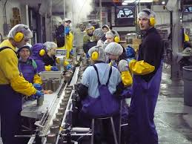
3. Seasonal Fish Processor at Trident Seafoods
These jobs are demanding seasonal jobs that pay reasonably well – mostly because there is a lot of overtime work and very little opportunity to spend money. But for the right candidate, they can be an excellent opportunity to save a lot of money in not much time.
Minimum Qualifications:
- Must be interested in working 12-16 hours per day, seven days a week
- Can work legally in the US
- Must pass a drug test
Advantages:
- Summer processing jobs do not require work history and it is not necessary to be fluent in English. You also can get a job with drug or alcohol convictions - the hiring managers are mostly concerned that your record does not show a pattern of such offences.
- If you finish the season, your airfare and most of your expenses (including room and board) will have been paid for - so it's an excellent way to save up money quickly.
- If you work on a floating processor, you can advance onto the deck or engine crew through hard work and positive interactions with the existing crew. You can also get jobs on a salmon tender without an AB or OS through your experience as a processor.
- Year-round opportunities also exist in Seattle at Pier 91 and in Everett - especially if you have welding or electrical skill. Temp agencies like Labor Ready also contract often with Trident.

Other Qualifications: Ideal applicants for seasonal seafood processing have a consistent work history and are willing to be flexible and transfer to different processing plants throughout Alaska.
Pay Rate: Pay varies depending on the season and how many fish are being caught, but entry level workers can expect to work for $7.75/hour (with overtime at $11.62/hour) for about 100 hour weeks. A good six week season could net about $6000
How to Apply: Fill out an application online at http://www.tridentseafoods.com, under "Join Our Team." Pick the button that says "Seasonal Jobs," then find one of the jobs listed under the title "processor." Don't worry too much about where you choose to go - the recruiter will finalize that with you at your interview, and can help you match your location to the kind of work you want to do and your time frame. Then, attend an interview. The interviewer will spend about five minutes with each applicant. If you are offered a job you must then complete a health questionnaire and show up on the day you are scheduled to start.
When to Apply: Trident does major hiring for its seasonal jobs twice per year (early winter and early summer), and then a smaller amount of hiring in early spring.

4. Gillnets in Bristol Bay, Alaska
This is a summer-time position fishing for salmon in beautiful Bristol Bay, Alaska. Pay depends on the year’s catch, the pay structure (by the hour vs. a percentage of the boat’s catch), and the particular boat you work on (set-net vs drift gillnet) – but it can average to about $5,000 a summer.
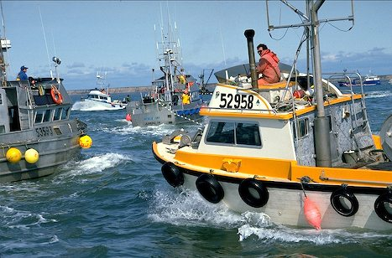
Minimum Qualifications: Willing to work hard and potentially without much sleep; can get along with people while living in close quarters.
- Must be over 18
- Must have a state ID
Some employers will do drug testing and expect employees to be drug and alcohol free for the season; others don’t necessarily care.
Advantages: Applicant does not need any maritime licenses or paperwork; employer will often pay for food, housing, and transportation to Alaska; colorblindness isn’t a problem; room for advancement in smaller boats. Pay is either a certain percentage of the catch or a flat wage rate.
Other Information: The salmon season runs from mid-June to July or August; canneries will open a bit earlier and close a bit later. Strong applicants will have strong references, as most hiring is through word of mouth.
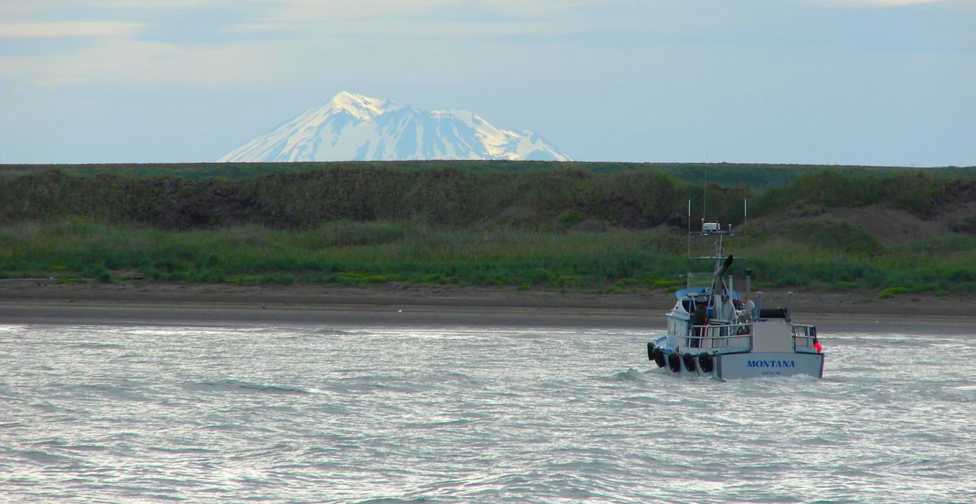
To Apply: Most of the jobs in this area tend to be gotten through word of mouth and family connections, but there are jobs posted on Craigslist and the classifieds on naitonalfishermen.com, wwoofish.com, and workboat.com.

Apprenticeships in the Skilled Trades
The opportunities listed in this section are job-based training programs that provide training for a variety of maritime careers. All are paid and will eventually lead to a journeyman certification in the industry. The apprenticeship programs listed in this section currently focus on shore-based vocations like painting, bright work (having to do with varnishing wood on a boat), repair, electrical, rigging, sail-making, welding, cabinetry, longshoremen (a person who loads and unloads ships), and much more! Also keep in mind that several of the programs listed in previous sections can help applicants navigate the application process for these jobs – most notably ANEW’s Apprenticeship Opportunities Program. You don’t have to go it alone!
- Boilermakers (1) assemble, install, and repair boilers, close vats, and other large vessels or containers that hold liquids and gases. Median pay for a boilermaker is $27.19 per hour.
- Refrigeration Fitters (2) install and service all types of refrigeration and air conditioning systems.
- South Seattle Community College (3) offers boilermaker and marine electrician apprenticeships at their Georgetown Campus. Descriptions of these (and other non-maritime specific) programs can be found at http://georgetown.southseattle.edu/AEC/apprenticeships.aspx.
- Other Apprenticeship Opportunities (4) are always being posted at the Labor and Industries website. Some relate to maritime and others do not, but all are good opportunities!

Apprenticeship Opportunities:

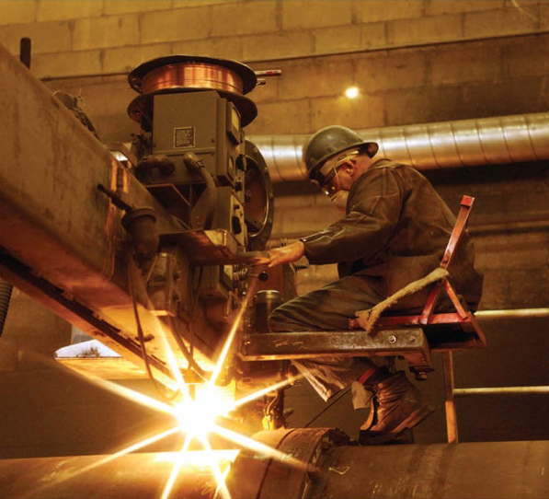
1. Boilermaker Apprenticeships in Seattle, WA
Boilermakers assemble, install, and repair boilers, close vats, and other large vessels or containers that hold liquids and gases. Median pay for a boilermaker is $27.19 per hour.
Minimum Qualifications:
- Must be over 18
- High school diploma or GED
- Must provide photocopies of Birth Certificate and Diploma or GED
- Legal right to work in the United States
Other Information:
- Must be physically capable of performing the work of the trade, including the possibility of working in confined spaces or at great heights.
- Complete at 6000 hour comprehensive training program.
- Attend 144 hours of classroom instruction per year on personal time.
- Drug/alcohol test required after taking apprenticeship
To Apply: Call (928) 645-0277 for more information, email westernstatesjac@gmail.com, or look for more information at Boilermakers Local #502, 16621 110th Avenue East, Puyallup, Washington, 98374, (253) 435-0332.

2. Refrigeration Fitters Apprenticeship in Seattle, WA
Refrigeration fitters install and service all types of refrigeration and air conditioning systems. This includes commercial, industrial, and residential applications and, in addition to the related piping, they also set and connect all of the specialized equipment necessary for the job.
Minimum Qualifications:
- Must be over 18
- High school diploma or GED
- Passed the Compass Exam
- Legal right to work in the United States
- Valid WA Driver’s License
Other Information:
- Must be physically capable of performing the work of the trade, including the possibility of working in confined spaces or at great heights.
For More Information: Call (360) 486-9400, or visit the Southwest Washington Pipe Trades Training Center, 8501 Zenith Court NE, Lacey, Washington, during normal business hours. Currently, the JATC office is open Monday through Friday 8:00 am – 12:00 pm and 1:00 pm – 5:00 pm; excluding holidays.

3. South Seattle Community College Apprenticeship Programs:
The Georgetown Campus of SSCC offers a variety of apprenticeship programs, including Marine Electrician and Boilermakers. Visit http://georgetown.southseattle.edu/AEC/apprenticeships.aspx for the most up-to-date information.
Information on Boilermaker Apprenticeship:
Boilermakers are complete metal fabricators who build and repair ships, fishing boats, ferries, barges, cranes, offshore drilling platforms, boilers, tanks, pressure vessels, plate and structural fabrications. Boilermakers perform welding, automatic and manual burning, blueprint reading, layout and template making, CAD (computer aided drawings), rigging, operation of mobile and stationary cranes, operation of shears, brakes, rolls, drill press, saws and all other metal fabrication equipment.
Contact: Phone: (206) 624-470, Email: boilermakerapprenticeship@gmail.com
Information on Marine HVAC and Electricians:
This program includes basic electrical training, blueprint reading, power tool skills training, repair of electrical boxes, electrical materials, ship construction techniques, including tanks, wire-ways, welding brackets, cabling, tagging, power generation, power distribution, load testing of AC/DC systems, lighting, phones, propulsion system cabling, weapon systems, communication systems, combat information center systems, welding, testing and industrial safety courses. The Marine Electrician is able to install, repair and maintain marine electrical systems. Completion of the apprenticeship allows the student to apply for an EL01 License.
Contact: Phone: (253) 395-6500, Email: harry@ibew46.com

4. Labor and Industries Approved Apprenticeship Programs:
The Washington Department of Labor and Industries keeps a list of apprenticeship programs that have current openings in the state. Prospective applicants can search by county, type of program, or availability. Most of these are focused on the construction trades, but are certainly worth taking a look at. See http://www.lni.wa.gov/TradesLicensing/Apprenticeship/Programs/default.asp for more information.

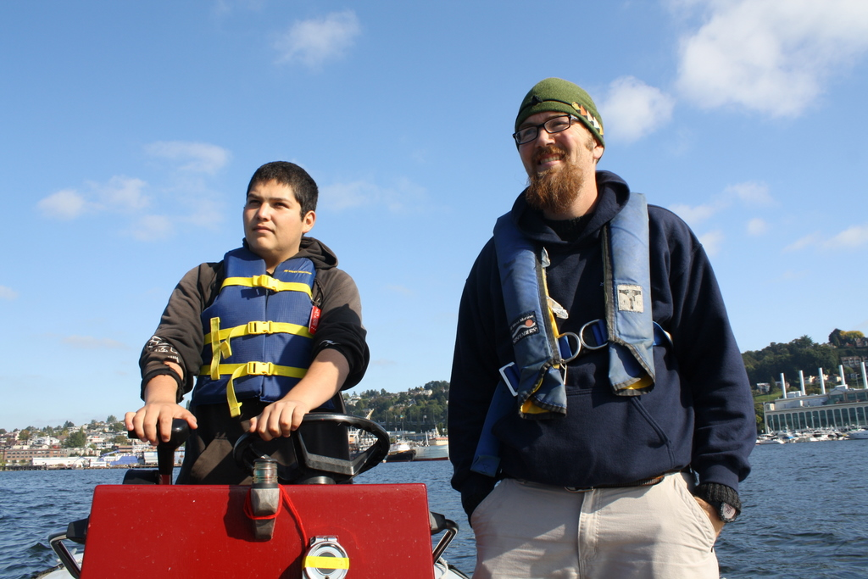
Maritime Training Programs
The programs in this section offer unparalleled opportunities to gain traction in the maritime industry, but they are specifically for young people. A strong desire to go into a maritime career is a prerequisite for any of these programs.
- The Job Corps Seamanship Program (1), in Astoria, Oregon, is a free program that prepares students to work on boats with some of the most basic certifications needed for both deck and engine room positions.
- The Paul Hall Center (2), in Piney Point, Maryland, offers free tuition and a guaranteed first job after graduation to students who can pay to get to and from the training center.
- The Anchor Program (3), based in Seattle and Richmond, CA, offers maritime training to underserved youth. Find out more at www.theanchorprogram.com

Program Descriptions

1. Job Corps Seamanship Program in Astoria, OR
For young people (16-24) who know they want to work on boats, Job Corps offers the chance to get credentials, a GED, and gain experience in the industry. Individuals are expected to commit up to two years to the program.
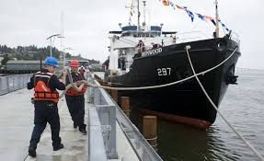
Requirements:
- Be age 16-24
- Meet income guidelines
- Legal to work in the US
- Be able to test clean by the first day of the program
- Be able to read at the 9th grade level
To Apply: Applying for the Seamanship Program can take quite a while, as there is a 6-12 month waiting list (it is the only program of its kind in the US).
- Attend an orientation (which are held every single week in various locations)
- Complete an application packet (including birth certificate, passport, social security card, school information, a TWIC card, a union referral from the IBU)
- Have a one-on-one interview and complete a health questionnaire (seamanship applicants cannot have major unmanaged medical issues and must have color vision)
For More Information: Contact Donelle Akers at (206) 622-6593 x 15, or akers.donelle@jobcorps.org

2. Paul Hall Center at Piney Point, MD
For applicants who want to take a maritime career to the next level and can pay for the costs of a passport and various other sundries - this may be the place!
Minimum Qualifications:
- Must be 18 or older
- Must be eligible to work in the United States. Must be able to get an MMC and TWIC card.
- Cannot be on any form of probation or parole
- Physical Requirements: Teeth in good medical condition, normal blood pressure, color vision, have good corrected vision
Advantages: The school's apprenticeship program is completely free (except transportation to Piney Point, MD), and students will be guaranteed a first job after graduation.
To Apply: Go to http://www.seafarers.org/jobs/ua.html and fill out the application. It is a very involved, several part application process, including an essay and getting your MMC and TWIC card. You can also call 1-877-235-3275 for more information.

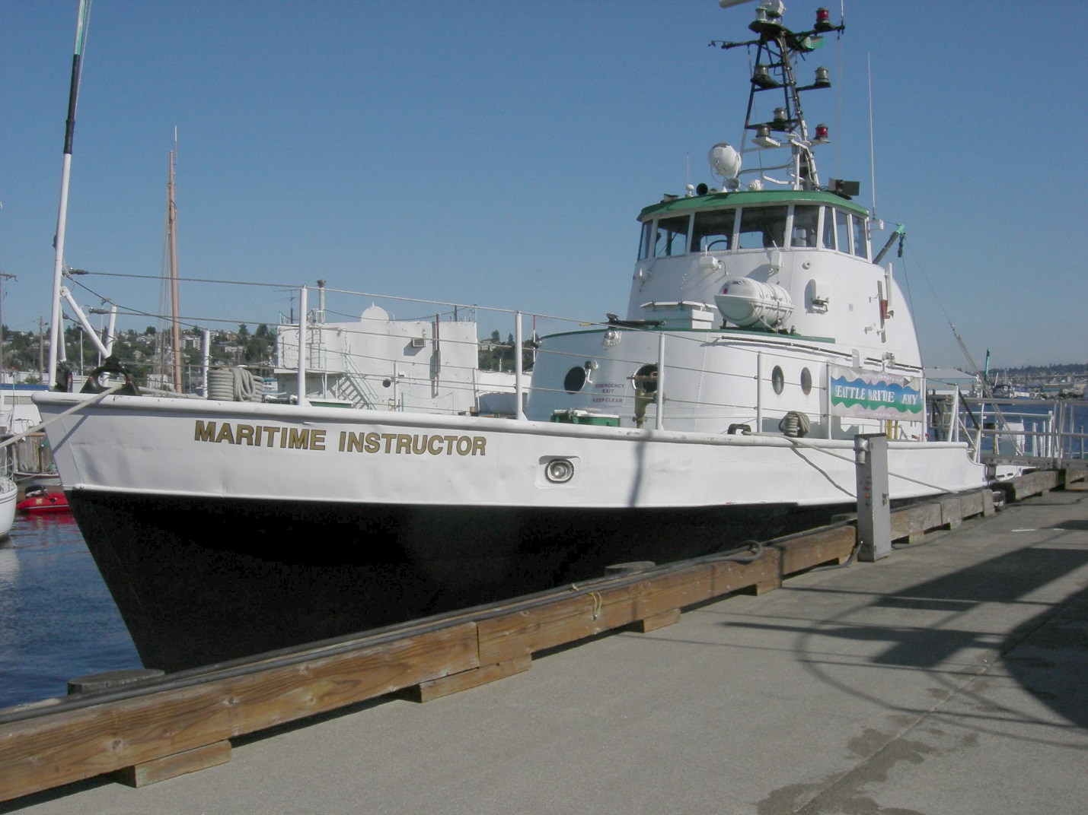
Community College Programs
The programs in this section offer unparalleled opportunities to gain traction in the maritime industry, but they require a level of commitment and screening that may be a huge barrier to some. A strong desire to go into a maritime career is a prerequisite for any of these programs.

Seattle-Based Programs:
- The Vigor/SCC Shipyard Welding Program (1) is a partnership between South Seattle Community College and Vigor industrial. Students will be prepared for shipyard-specific welding positions in this two quarter program.
- The Seattle Maritime Academy (2) offers on-the-water training in marine engineering and deck technology, preparing students for an entry level position on a boat. Seattle Central also offers a certificate in Marine Carpentry (Boatbuilding).

Regional Programs:
- The Skagit Valley College Marine Maintenance Technology (3) program in Anacortes, is focused on boat-building and repair. For those interested in the new field of sustainable maritime careers, this program is one of the best local schools to learn innovative new techniques.
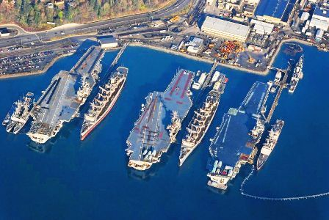
- The Apprentice Program at the Puget Sound Naval Shipyard & Intermediate Maintenance Facility (4), in Bremerton, WA offers paid tuition, on-the-job training, and career opportunities through a four year school program at Olympic College.
- Clatsop Community College (5) offers practical, on-the-water courses for entry-level deck positions. An introduction to maritime careers is also offered.
- Other Regional Programs (6) that offer certificates in marine manufacturing and technology are listed, along with the type of certificate they offer.

Other Concerns:
- Free Tuition: Puget Sound Naval Shipyard
- On-the-Water Training: Seattle Maritime Academy and Clatsop Community College
- Land-Based Training: VIGOR, Puget Sound Naval Shipyard, Skagit Valley College Marine Maintenance Technology Program, Other Regional Programs
- Financial Aid Resources are listed in the descriptions for various opportunities, but many low-income students qualify for aid in the form of grants or loans. See www.startnextquarter.org for some options in the Seattle area. Generally, the best advice for funding is to go to the Workforce Office – not the regular financial aid office – because most of the funding (basic food, worker retraining, WorkFirst, etc) is only through the Workforce office. WIA funding is also available through WorkSource agencies and could be a potential source of funding.

Program Descriptions: Seattle-Based Programs

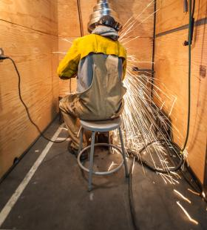
1. Vigor/SCC Shipyard Welding Program in Seattle, WA
You'll be prepared for shipyard-specific welding and fitting positions with wages of $14-$20 an hour—and begin a career path to higher-level training and higher-paying jobs.
Minimum Qualifications: Mechanical abilities and interests and in need of updated skills or retraining for the manufacturing industry
- Must be over 18
- Able to pass a drug test
- High school diploma or GED
- Math skills at a pre-algebra level
- Can understand, read, and write English at an intermediate level
Funding Eligibility: Some funding may be available if you are any one of the following:
- Low income and/or unemployed
- Receiving unemployment or basic food stamps
- A Veteran
Important Dates and Class Times:
- Information Sessions – May 29 and June 5
- Preparation Training – June 10 – June 28
- Class Times – July 1 – December 13 (two quarters), 9am-2pm Monday-Friday
To Apply: Call (206) 934-5814, email Mary.Lockman@seattlecolleges.edu, or look for more information at www.southseattle.edu.

2. Seattle Maritime Academy (Seattle Central Community College)
This program, though Seattle Central Community College, trains students for a career in the maritime industry. It includes classroom instruction, on-the-water training, and an at-sea internship. 95% of graduates find work in the maritime industry.
Minimum Qualifications:
- Must be over 18
- High school diploma or GED
Funding Eligibility: Seattle Central offers funding in the form of grants, federal loans, and scholarships. See http://seattlecentral.edu/payforcollege/index.php for more information.
To Apply / More Information: Call (206) 934-2647, dflath@seattlecolleges.edu, or look for more information at http://seattlecentral.edu/maritime/

Program Descriptions: Regional Programs

3. Marine Maintenance Technology at Skagit Valley College in Anacortes, WA
In this one to two-year program, you'll learn the skills and receive the training you need to launch your career in boat and shipbuilding and repair-refit industries.
Minimum Qualifications:
- Must be over 18
- High school diploma or GED
- Can understand, read, and write English at an intermediate level
For More Information: See http://www.skagit.edu/directory.asp_Q_pagenumber_E_209

4. Apprentice Program at the Puget Sound Naval Shipyard & Intermediate Maintenance Facility in Bremerton, WA
Student Trainees (Apprentices) are paid while attending classes at Olympic College during regular working hours Monday through Friday, every two weeks. The two weeks following the school weeks are full on-the-job training workweeks.
Minimum Qualifications:
- 18 years old
- US Citizenship
- Placement Exam Scores or Equivalent Transcripts
- Physical Capacity Exam
- Medical Exam
- Security Clearance
For More Information: See http://www.navsea.navy.mil/shipyards/puget/page/StudentTrainee.aspx

5. Clatsop Community College in Astoria, OR
Clatsop Community College offers three options for students seeking a degree in the field – a two-year program for students aiming to gain an entry level position, a one-year certificate, and an introductory course to the maritime industry. Keep in mind that Washington residents will need to pay out-of-state tuition for this program.
For More Information: Visit the Clatsop Community College website.

6. Marine Manufacturing & Technology Programs and Related Programs
An updated version of this list can be found on the Northwest Center of Excellence for Marine Manufacturing and Technology website.
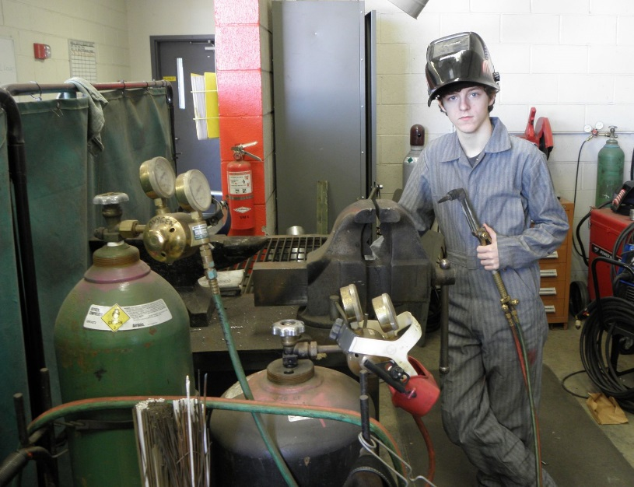
- Bellingham Technical College: www.btc.ctc.edu
  - Welding Technology
  - Heating, Ventilation, Air Conditioning & Refrigeration (HVAC)
- Big Bend Community College: www.bigbend.edu
  - Welding

- Clark College: www.clark.edu
  - Mechatronics (Combines electronics and engineering)
  - Welding Technology

- Clover Park Technical College: www.cptc.edu
  - Material Science: Composites
  - Welding Technology
- Columbia Basin College: www.columbiabasin.edu
  - Manufacturing Technology
  - Welding Technology
- Compass Courses: www.compasscourses.com
  - Basic Safety Training
  - Radar
  - Firefighting
  - PSC/Lifeboatman
  - Able Seaman
  - Bridge Resource Management
  - Captain/Mate
- Crawford Nautical School: www.crawfordnautical.com
  - Tankerman PIC
  - Radar
  - Bridge Resource Management
  - Engineering
- Edmonds Community College: www.edcc.edu
  - Materials Science Technology

  - Manufacturing & Materials Technology
- Everett Community College: www.everettcc.edu
  - Advanced Manufacturing & Composites
  - Welding & Fabrication
- Grays Harbor College: www.ghc.edu
  - Welding Technology
- Green River Community College: www.greenriver.edu
  - Machining & Manufacturing Technology

  - Welding Technology

- Lake Washington Institute of Technology: www.lwtech.edu
  - Electronics Technology
  - Motorcycle, Marine & Power Service Technology
  - Welding Fabrication & Maintenance
- Lower Columbia College: www.lowercolumbia.edu
  - Mechanical Engineering Technology
  - Manufacturing
  - Welding
- North Pacific Fishing Vessel Owners Association: www.npfvoa.org
  - Basic Safety Training
  - Firefighting & Personal Survival Techniques
  - Emergency Drill Instructor Workshop
  - Medical Emergencies at Sea
- North Seattle Community College: www.northseattle.com
  - Electronics Engineering Technology
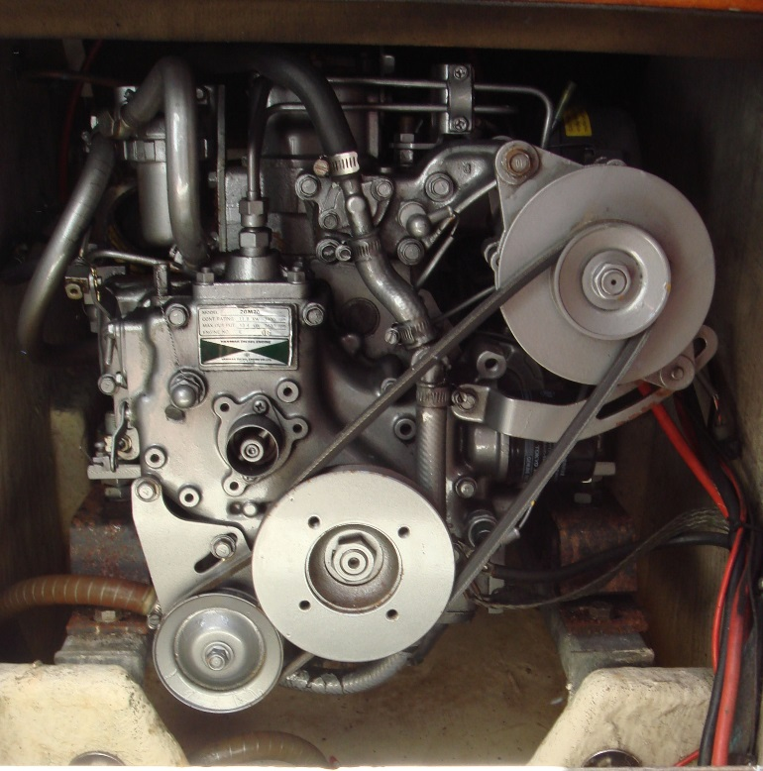
  - Electronics Technology
- Olympic College: www.olympic.edu
  - Electronics
  - Industrial Trades
  - Manufacturing Technology
  - Welding
- Peninsula College: www.pc.ctc.edu
  - Composite Structures
  - Welding
- Renton Technical College: www.rtc.edu
  - Welding
  - Refrigeration Technology
- Shoreline Community College: www.shoreline.edu
  - Manufacturing
- Skagit Valley College: www.skagit.edu
  - Composites Technology
  - Marine Systems
  - Marine Propulsion
  - Welding Technology
- South Puget Sound Community College: www.spscc.ctc.edu
  - Welding
- South Seattle Community College: www.southseattle.edu
  - Diesel and Heavy Equipment
  - Engineering Technology
  - Welding Fabrication Technology
- Spokane Community College: www.scc.spokane.edu
  - Heating, Ventilation, Air Conditioning & Refrigeration (HVAC/R)
  - Hydraulic and Pneumatic Automation Technology
  - Welding and Fabrication
- Walla Walla Community College: www.wwcc.edu
  - Welding Technology
- Wenatchee Valley Community College: www.wvc.edu
  - Electronics
  - Welding and Fabrication
- Pacific Maritime Institute: www.mitags-pmi.org
  - AB to Mate Program
  - Chief Mate/Master Program
  - Workboat Academy Program
- Fremont Maritime: www.fremontmaritime.com
  - Basic Safety Training
  - Firefighting
  - Damage Control
  - Lifeboatman, Towing, and Fast Rescue Boat
  - Fishing
  - Medical Care Provider
  - Superyacht Training
  - Tankerman PIC
- Northwest School of Wooden Boat Building: www.nwboatschool.org
  - Contemporary Boatbuilding
  - Traditional Large Craft
  - Traditional Small Craft

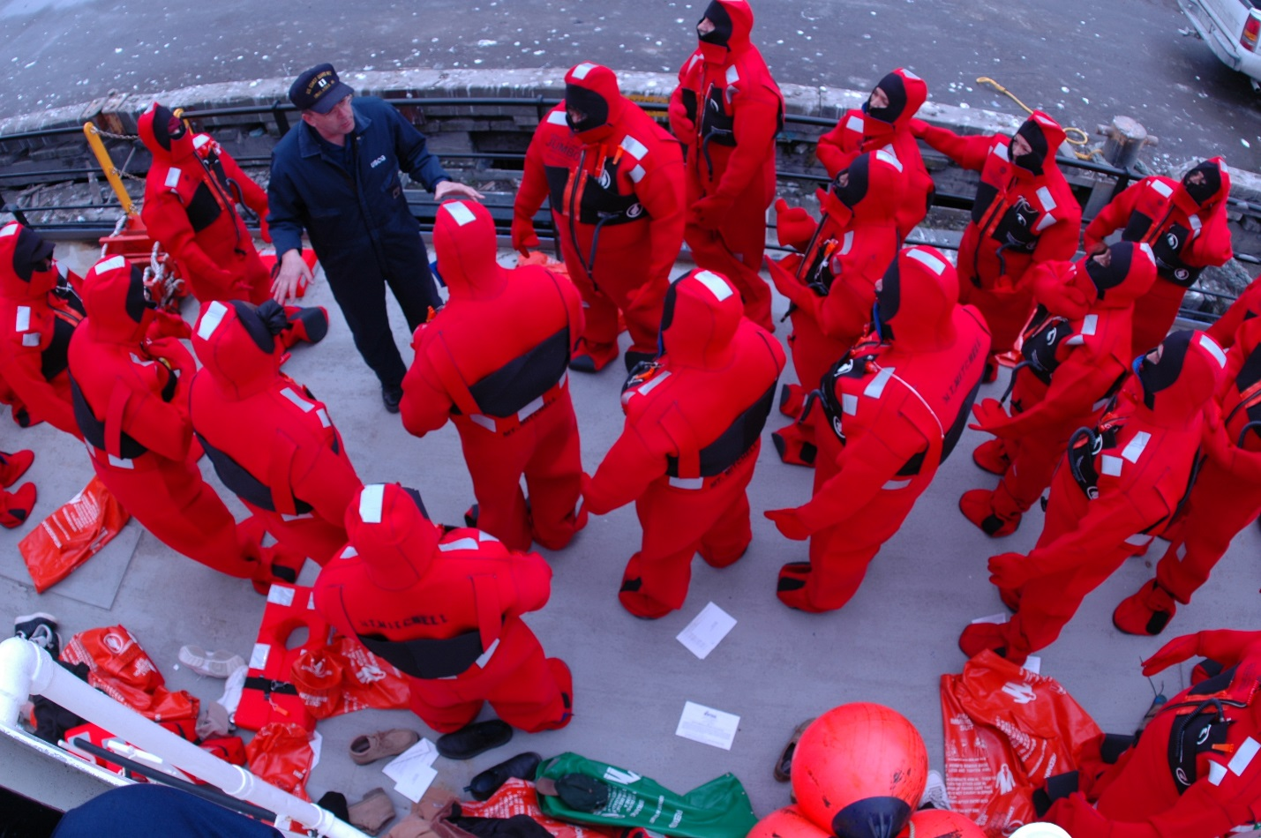
Professional Training for Mariners
Whether you’re a new or experienced mariner, these programs can help you advance.
  - Compass Courses (Edmonds, WA) - A professional maritime training school with over 20 USCG/STCW approved courses, including Basic Safety Training, Able Seaman, STCW, and RFPNW. http://compasscourses.com/
  - Crawford Nautical School (Seattle, WA) - The oldest privately-owned maritime training school in the United States, Crawford Nautical School has been training mariners from all areas of sea-going life -- deep sea, coastal and inland waters; Masters, Mates, Pilots and Engineers for over 90 years. http://crawfordnautical.com/
  - Flagship Maritime Training Center (Tacoma, WA) – Flagship’s course offerings include OUPV (Operator of Uninspected Passenger Vessel) certification, an upgrade from OUPV to a 100-ton master’s license, and radio and rescue boat certifications. Enrollment in Flagship’s courses automatically includes full credentialing services (meaning that they will help you get all your Coast Guard documents in order.) http://www.flagshipmaritimetraining.com/
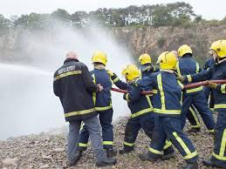
  - Fremont Maritime Services (Seattle, WA) – Fremont Maritime works to prepare professional mariners for fire, flooding, abandon ship, and man overboard emergencies – and works with large fishing, towing, cargo, and passenger companies to do so. http://www.fremontmaritime.com/
  - NPFVOA Vessel Safety Program (Seattle, WA) - NPFVOA Vessel Safety Program offers 13 Coast Guard-approved hands-on safety training classes for mariners of all kinds, including commercial fishing, small passenger, workboat, and research vessel crews. Most classes are held at classroom at Fishermen’s Terminal in Seattle, or onboard vessels. However, locations are flexible, and past classes have been held throughout Alaska, California, Hawaii, Oregon, and Washington. Each course is 8 hours in length unless otherwise indicated. http://npfvoa.org/vessel-safety-classes/
  - Fryar’s Maritime Service (Vancouver, WA) – Offers training for maritime personnel pursuing maritime profession or upgrading their current license or merchant mariner's document by offering U. S. Coast Guard approved courses and License Examination Preparation. Fryar’s utilizes an online curriculum and tutoring, making it a good choice for professionals who can dedicate themselves to studying at home, underway, and at their own pace. http://www.maritimetesting.com/pages/index.php
  - Pacific Maritime Institute (Seattle, WA and Baltimore, MD) – MITAGS-PMI has a range of classes – from ordinary seaman to unlimited tonnage master/pilot – that focus on helping professional mariners advance. This includes a range of comprehensive programs, courses, USCG Examination Assistance, and Maritime Simulation including advanced Training and Research capabilities. mitags-pmi.org/
  - WA State Patrol Fire Training Academy Marine Firefighter Training (North Bend, WA) - The Washington State Fire Training Academy in North Bend, Washington, provides an STCW Marine Firefighting course. http://www.wsp.wa.gov/fire/ftatrain.htm#marine

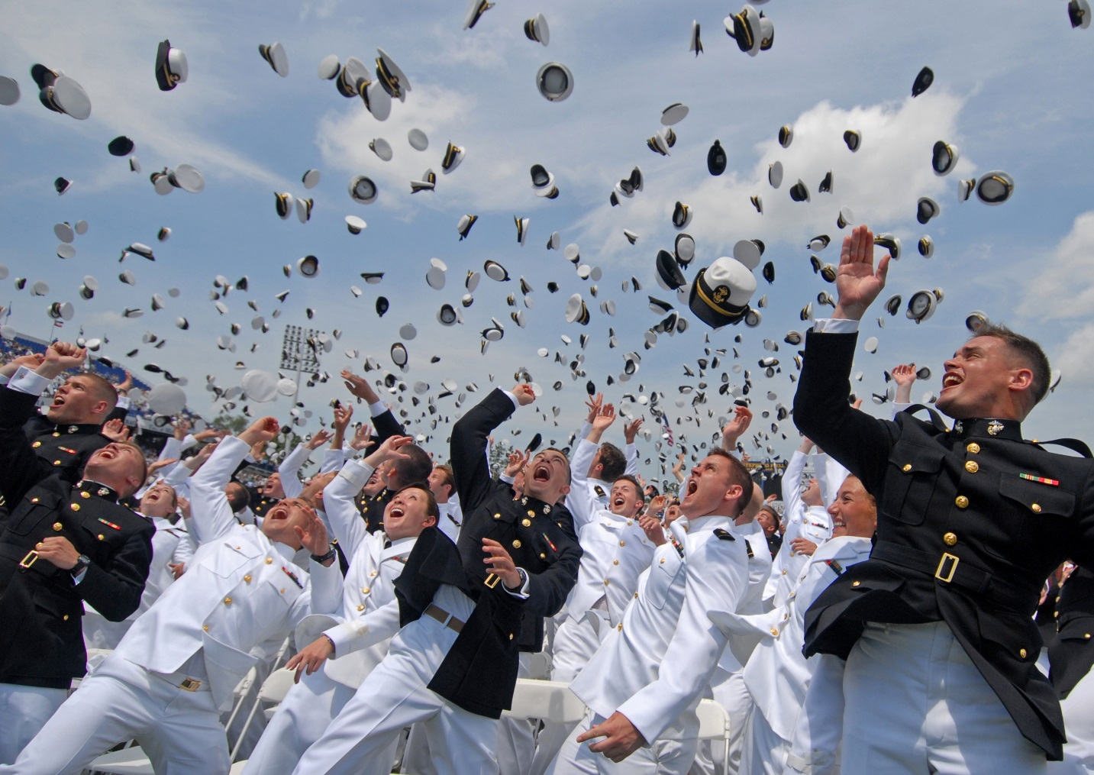
Four-Year Maritime Colleges
Whether you’d like to go to sea or not, there is a host of options that offer you the chance to earn a four-year degree plus a specific maritime skill set.

Civilian Maritime Academies
All of the seven degree-granting maritime academies in the United States offer multiple degrees, including several non-seagoing programs that focus on international business, logistics, and maritime affairs. As such, they require students to have a very good command of academic tasks (including a focus on math and science) as well as the discipline to live on their own.

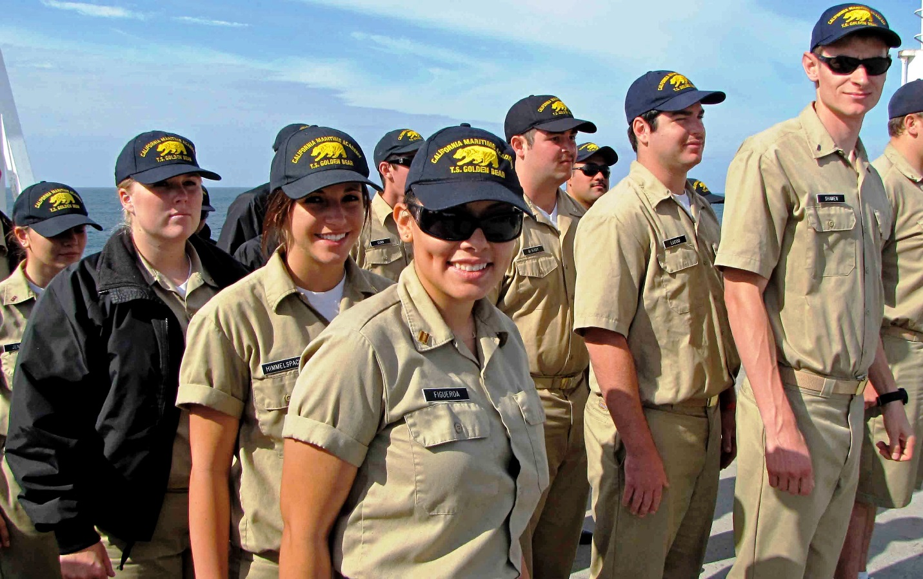
Seagoing majors in Marine Transportation will generally earn credentials that qualify them to be a Second (or Third) Mate and Officer in Charge of a Navigational Watch (pending successful completion of a Coast Guard exam); Engineering majors generally earn their Third Assistant Engineer license. Each prepares students for work at the officer level on ocean-going, cargo, tank, and work boats.

- California Maritime Academy, (Vallejo, CA)
  - Unique Features: Cal Maritime is the only Maritime Academy serving the West Coast
  - For More Information: https://www.csum.edu/
- Great Lakes Maritime Academy, (Traverse City, MI)
  - For More Information: https://www.nmc.edu/maritime/admissions/
- State University of New York Maritime College, (Throggs Neck, NY)
  - For More Information: www.sunymaritime.edu/
- U.S. Merchant Marine Academy, (King's Point, NY)
  - Unique Features: USMMA is the only federal academy, and it is unique in that students do not have to pay for tuition, room and board, uniforms, and books.
  - For More Information: www.usmma.edu/
- Texas Maritime Academy, (Galveston, Texas)
  - For More Information: www.tamug.edu/corps/
- Maine Maritime Academy (Castine, ME)
  - For More Information: mainemaritime.edu/
- Massachusetts Maritime Academy (Buzzards Bay, MA)
  - For More Information: www.maritime.edu/
Minimum Qualifications:
- Must have at least a high school diploma and good grades
- Fulfill basic college requirements
- Have taken math at least through pre-calculus
- Ability to live independently and as part of a tight school community; also a desire to lead but also good responsiveness to military-style discipline and structure

Financing an Education:
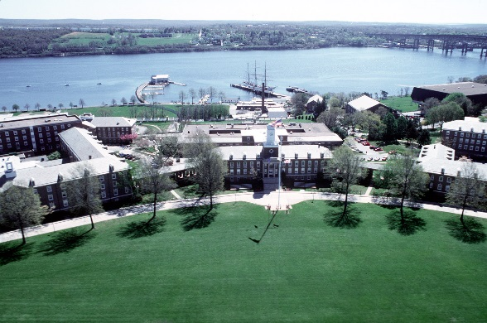
- Students at any of the seven academies may apply for aid through federal programs (www.fafsa.gov) or through private scholarship funds
- Programs in your region are often cheaper through agreements between states (i.e. the Western Undergraduate Exchange for Washington residents interested in Cal Maritime)
- Most academies boast of an over 95% job placement rate in the first year after graduation, and many students pay off their loans within 5 years of graduation

Military Training Academies
- U.S. Coast Guard Academy, (New London, CT)
- U.S. Naval Academy, (Annapolis, MD)

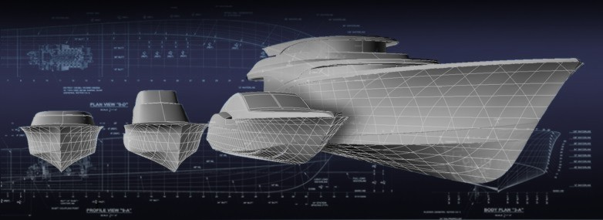
Naval Architecture, Marine Engineering, and Ocean Engineering Programs
There are many programs throughout the United States (and the world!) that focus on learning the skills associated with vessel design. The Society of Naval Architects and Marine Engineers has an excellent full listing of schools that have courses in these subjects on their website – and there are many other resources for prospective students online!
A short listing of schools with programs in in Marine Architecture, Powerboat Design, Marine Engineering, or Naval Architecture follows:
Florida Atlantic University: Ocean Engineering program. Boca Raton, FL. http://www.ome.fau.edu/
MIT – Massachusetts Institute of Technology: Undergraduate Ocean Engineering and Graduate Ocean Engineering/Naval Architecture and Marine Engineering courses. Cambridge, MA. http://web.mit.edu/2n/
State University of New York Maritime College: A four-year college of the State University of New York offering Marine Engineering, Electrical and Electronic Systems, Facilities Engineering, Marine Operations, Naval Architecture, and Small Vessel Operations. www.sunymaritime.edu
The Landing School: A full-time post-secondary vocational school specializing in education for careers in the marine industry as boat builders, designers and marine system technicians. Kennebunkport, Maine. http://landingschool.edu/
University of California Berkeley: The Department of Naval Architecture and Offshore Engineering was disestablished in 1998. UC Berkeley now offers studies in Ocean Engineering. http://www.me.berkeley.edu/Grad/Areas/ME_Main_Frame_Ocean_Eng.htm
University of Michigan: Department of Naval Architecture and Marine Engineering. Ann Arbor, MI. name.engin.umich.edu
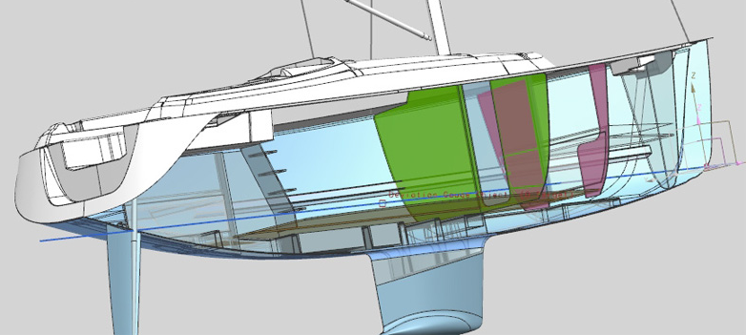
University of New Orleans: Teaching the theoretical and applied aspects of form calculations and stability, offshore structure and ship strength, ship resistance and propulsion, ship dynamics, small craft design, marine materials and admiralty law, hydrodynamics, computer-aided design, and ship production by IPPD methods. http://www.uno.edu/coe/naval-architecture-marine-engineering/
Webb Institute of Naval Architecture: Undergraduate BS degree in Naval Architecture and Marine Engineering. All students admitted to Webb receive a four year, full tuition scholarship. The only fees are room and board, books and personal expenses. Another unique aspect is the yearly Winter Work Term during which students are required to work in the maritime industry. Glen Cove, NY. www.webb.edu
Westlawn Institute of Marine Technology: Nationally accredited, internationally recognized school offering professional courses in yacht design and related marine technology subjects through distance study. The not-for-profit educational affiliate of the National Marine Manufacturers Association. www.westlawn.edu

Getting In: An Example Path
Webb Institute is a four-year, fully accredited engineering college that specializes in naval architecture and marine engineering. Every Webb student (who is a U.S. citizen or Green Card holder) receives a full-tuition scholarship, though room and board are not included. Since there are only 20-24 students per year, the process is particularly competitive! An admissions officer at Webb gave the following thoughts about who is a good fit for Webb:
Minimum Qualifications:
- Academically strong, with high school math up to Calculus and a full year of physics and chemistry. Most Webb students score over 600 on their Verbal SAT, and over 700 in Math.
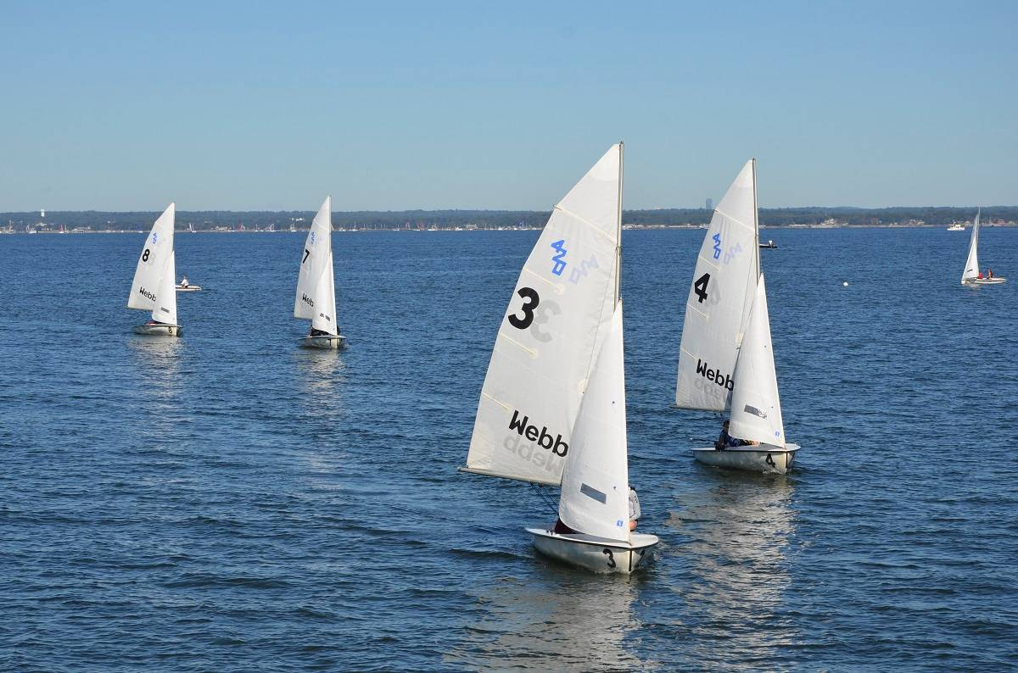
- Demonstrate an interest in how things work through extracurricular activities like robotics, mathletes, lego-building, etc. An interest in “messing around in boats” is also helpful, but not required
- Webb students have a large course load and little flexibility not to pass classes, so they are looking for strong academic students
Application Process:
- SAT, CollegeBoard subject tests in Math/Physcs
- Next phase – interview @ Webb. They are looking for answer to: “How well have you thought out a career in engineering?” Have a fund helping people get there if that is a barrier

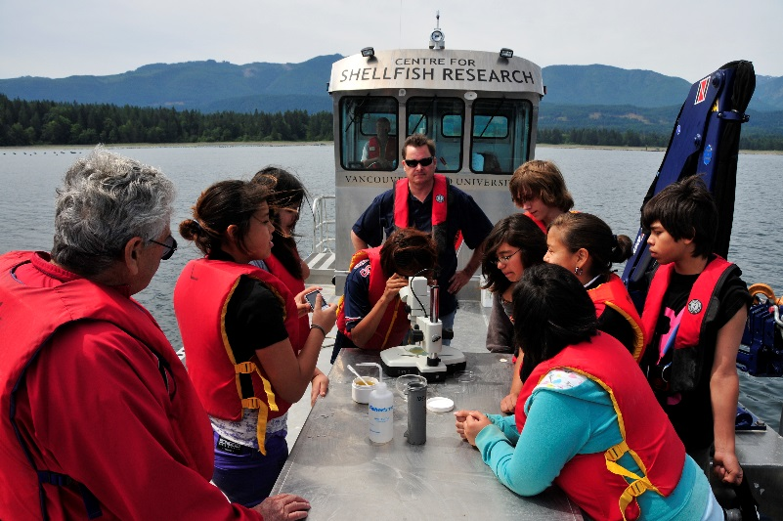
Training for Fisheries or Science Careers
There are many programs nationwide that offer training in Marine Biology, Oceanography, Fisheries Management, and more. In-state, the following programs are notable:
University of Washington Marine Biology Program - http://depts.washington.edu/marbio/
University of Washington School of Aquatic and Fisheries Studies - http://fish.washington.edu/
University of Washington School of Marine and Environmental Affairs - http://smea.uw.edu/
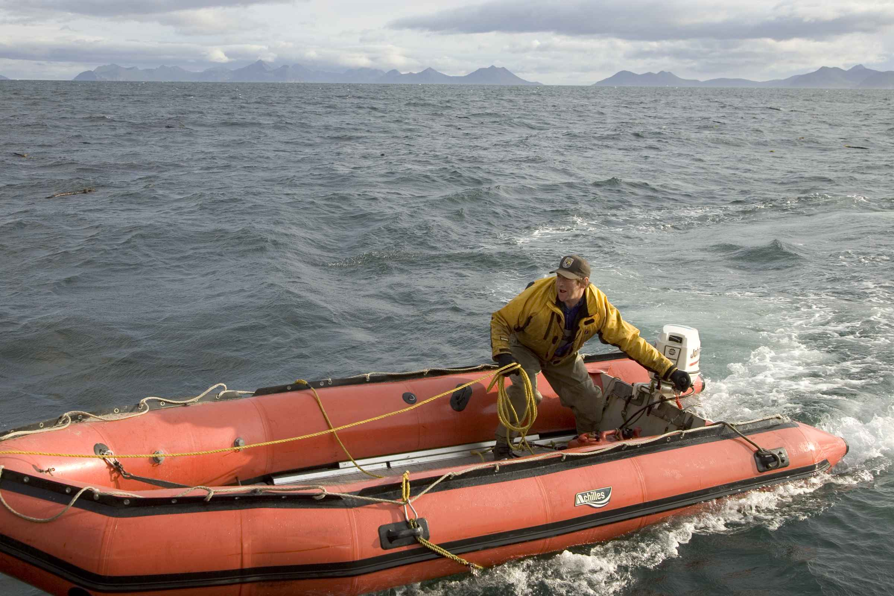

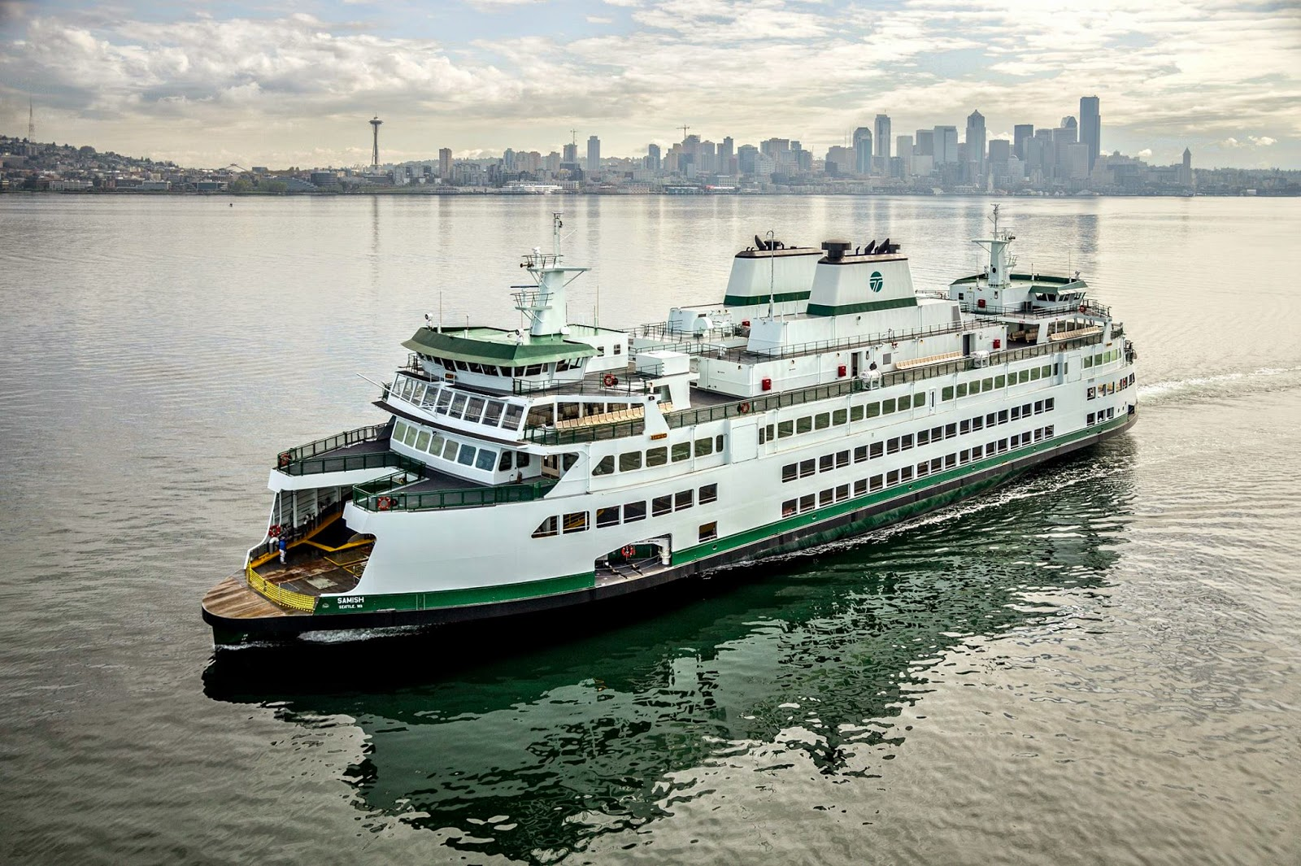

APPENDIX

Getting a TWIC Card: Disqualifying Offenses
DISQUALIFICATION, WAIVERS, AND APPEALS
Disqualification
What can disqualify me from getting a TWIC?
- An individual who lacks lawful presence and certain immigration status in the United States, has a connection to terrorist activity, has been determined to lack mental capacity or was convicted of certain crimes will be ineligible for a TWIC.
What if I do not meet the qualification standards?
- Applicants who are denied a TWIC will be notified of the reason for denial and instructed on how to apply for an appeal or waiver. Once issued a TWIC, the applicant has the continuing obligation to inform TSA if he or she is no longer eligible for a TWIC.
What are the disqualifying offenses? What are the waiver policies for each type of offense?
- Parts A and B provide a comprehensive list of disqualifying offenses and the waiver policies for each.
Part A – Permanent Disqualifying Offenses
Conviction for one of the following felonies is disqualifying regardless of when it occurred, and the applicant is not eligible for a waiver.
- Espionage or conspiracy to commit espionage.
- Sedition, or conspiracy to commit sedition.
- Treason, or conspiracy to commit treason.
- A federal crime of terrorism as defined in 18 U.S.C. 2332b(g), or comparable State law, or conspiracy to commit such crime.
Conviction for one of the following felonies is disqualifying regardless of when it occurred, and the applicant may apply for a waiver.
- A crime involving a transportation security incident. A transportation security incident is a security incident resulting in a significant loss of life, environmental damage, transportation system disruption, or economic disruption in a particular area, as defined in 46 U.S.C. 70101. The term "economic disruption" does not include a work stoppage or other employee-related action not related to terrorism and resulting from an employer-employee dispute.
- Improper transportation of a hazardous material under 49 U.S.C. 5124, or a State law that is comparable.
- Unlawful possession, use, sale, distribution, manufacture, purchase, receipt, transfer, shipping, transporting, import, export, storage of, or dealing in an explosive or explosive device. An explosive or explosive device includes an explosive or explosive material as defined in 18 U.S.C. 232(5), 841(c) through 841(f), and 844(j); and a destructive device, as defined in 18 U.S.C. 921(a)(4) and 26 U.S.C. 5845(f).
- Murder.
- Making any threat, or maliciously conveying false information knowing the same to be false, concerning the deliverance, placement, or detonation of an explosive or other lethal device in or against a place of public use, a state or government facility, a public transportations system, or an infrastructure facility.
- Violations of the Racketeer Influenced and Corrupt Organizations Act, 18 U.S.C. 1961, et seq., or a comparable State law, where one of the predicate acts found by a jury or admitted by the defendant, consists of one of the crimes listed in Column A.
- Attempt to commit the crimes in Part A, items 1 - 4.
- Conspiracy or attempt to commit the crimes in Part A, items 5 – 10.
Part B – Interim Disqualifying Offenses
Conviction for one of the following felonies is disqualifying if the applicant was convicted, pled guilty (including 'no contest'), or found not guilty by reason of insanity within 7 years of the date of the TWIC application; OR if the applicant was released from prison after conviction within 5 years of the date of the application. The applicant may apply for a waiver.
- Unlawful possession, use, sale, manufacture, purchase, distribution, receipt, transfer, shipping, transporting, delivery, import, export of, or dealing in a firearm or other weapon. A firearm or other weapon includes, but is not limited to, firearms as defined in 18 U.S.C. 921(a)(3) or 26 U.S.C. 5 845(a), or items contained on the U.S. Munitions Import List at 27 CFR 447.21.
- Extortion.
- Dishonesty, fraud, or misrepresentation, including identity fraud and money laundering where the money laundering is related to a crime described in Columns A or B. Welfare fraud and passing bad checks do not constitute dishonesty, fraud, or misrepresentation for purposes of this paragraph.
- Bribery.
- Smuggling.
- Immigration violations.
- Distribution of, possession with intent to distribute, or
importation of a controlled substance.
- Arson.
- Kidnapping or hostage taking.
- Rape or aggravated sexual abuse.
- Assault with intent to kill.
- Robbery.
- Fraudulent entry into a seaport as described in 18 U.S.C.
1036, or a comparable State law.
- Violations of the Racketeer Influenced and Corrupt
Organizations Act, 18 U.S.C. 1961, et seq. , or a comparable State law, other than the violations listed in Part A, item 10
- Conspiracy or attempt to commit felonies listed in Part B.
What if a conviction is "exonerated?"
- If a conviction is expunged or pardoned, the criminal records may reveal this. If they do not, TSA sends the applicant a Preliminary Determination of Ineligibility letter explaining what the records show and how the applicant can correct inaccurate records.
What if my initial disqualifying crime is no longer applicable? Can I reapply for a TWIC?
- Applicants are encouraged to reapply if their initial disqualifying offense is no longer applicable. Applicants will need to understand the nature of the initial disqualification and the corresponding look-back periods of 5 or 7 years if applicable. Reapplying can occur as long as there are no secondary disqualifying events.
What if I have a disqualifying crime that was expunged from my record?
- The applicant should proceed with TWIC enrollment as though they do not have a disqualifying offense, as long as the record is truly expunged. Per 49 C.F.R. §1570.3, a conviction is expunged when "the conviction is removed from the individual's criminal history record and there are no legal disabilities or restrictions associated with the expunged conviction, other than the fact that the conviction may be used for sentencing purposes for subsequent convictions." However, if the applicant is a credentialed mariner or intends to apply for a mariner credential, he or she must report convictions that were expunged on their application to obtain the MMC. Failure to disclose expunged convictions could result in a determination that the application for the mariner credential is fraudulent.
Can a person under indictment apply for a TWIC? Do they still have the appeal and waiver process available to them?
- An individual under indictment for a disqualifying criminal offense may not hold a TWIC until the indictment is dismissed. If the applicant has an indictment pending, the applicant could apply for a waiver; however, a request for a waiver does not guarantee that a waiver will be granted.
Waivers and Appeals
What options are available to me if I am initially determined to be ineligible for a TWIC?
- Applicants who are initially determined to be ineligible for a Transportation Worker Identification Credential (TWIC) will be provided with TSA's justification for denial, and instruction for how to apply for an appeal or waiver. The process is straight forward, and no legal knowledge is needed, nor is legal representation necessary. Requests may be typed or handwritten.
  - Appeal -- If you believe that you should not have been determined to be ineligible for a TWIC (i.e. you may think the decision was based on incorrect court records or incorrect information provided at enrollment), you may request an appeal. You may request copies of the materials that TSA used to make the determination to assist you in deciding whether a correction must be made to your court records and/or what information must be provided to justify your appeal.
  - Waiver -- If you have a disqualifying offense, meet the description of mental incapacity, or are an alien under temporary protected status, you may request a waiver. When completing a waiver request, the applicant should describe why he/she no longer poses a security threat. Information that assists TSA with this determination includes:
    - The circumstances surrounding the conviction.
    - The length of time the applicant has been out of prison if sentenced to incarceration.
    - The applicant's work and personal history since the conviction.
    - Whether the applicant made restitution or completed mitigation remedies, such as probation or community service.
    - References from employers, probation officers, parole officers, clergy, and others who know the applicant and can attest to his/her responsibility and good character.
    - If denied due to mental incapacity, court records or official medical release documents that relate to the applicant's mental health may also be included with the waiver request.
    - If an alien under temporary protected status, information attesting to that.
What options are available if I am denied an appeal or waiver?
- Appeals and Waivers Related to Immigration Status
  - If an applicant’s appeal or waiver is denied because he or she was unable to prove immigration eligibility to hold a TWIC, then the applicant may re-enroll when he or she has documents that prove immigration eligibility.
- Appeals Related to Disqualifying Criminal Offenses
  - If an applicant’s appeal is denied because he or she was unable to prove that a disqualifying criminal offense has been expunged or that the applicant has been pardoned, then the applicant may file a waiver.
- Waivers Related to Disqualifying Criminal Offenses
  - If an applicant’s waiver for a disqualifying criminal offense has been denied, then the applicant may request a review by an Administrative Law Judge (ALJ), a third party who reviews the information pertaining to an individual’s case.. Additional information on the ALJ process is available in section 49 CFR 1515.11.
What is the timeframe for submitting a request for an appeal or a waiver?
- Applicants must send appeal and waiver requests to TSA within 60 days of receiving TSA's Preliminary Determination of Ineligibility letter. If the applicant does not respond to TSA within 60 calendar days, TSA's decision regarding the applicant's eligibility for a TWIC automatically becomes final, and the applicant is disqualified from holding a TWIC.
- If an applicant needs more than 60 days to respond, then the applicant should send a letter to TSA asking for an extension. Any requests for time extensions will automatically be granted by TSA.
Where do I send appeals or waivers requests?
- Fax Number: 540-710-2763 OR 540-710-2783
- Mailed via U.S. Postal service (note: Registered Mail is accepted) to:
Transportation Security Administration
TSA TWIC Processing Center
P.O. Box 8118
Fredericksburg, VA 22404-8118
Please remember to include the cover sheet (that was provided with your letter from TSA) and all supporting documentation when faxing or mailing your material.
Can I see a sample Preliminary Determination of Ineligibility letter?
- Click here to see a sample letter. Note these letters are tailored to the individual and their circumstances.
- If someone has received an initial determination of ineligibility, can he or she access secure areas of a port pending the appeal/waiver process or does the applicant have to wait for its completion?
  - Access to these areas will depend on the owner/operator security plan and their escorting procedures, as well as the enforcement and compliance date for that particular USCG Captain of the Port zone.

Getting your Transportation Worker Identification Credential (TWIC) Card
The Transportation Worker Identification Credential (or TWIC) program is a Transportation Security Administration and U.S. Coast Guard initiative in the United States. The TWIC program provides a tamper-resistant biometric credential to maritime workers requiring unescorted access to secure areas of port facilities, outer continental shelf facilities, and vessels regulated under the Maritime Transportation Security Act of 2002, or MTSA, and all U.S. Coast Guard credentialed merchant mariners. (Wikipedia)
(from http://www.tsa.gov/what_we_do/layers/twic/twic_faqs.shtm#twic_process)
- Step One: Check Eligibility
  - An individual must be a U.S. citizen or fall into an eligible immigration category (click here for immigration categories) and cannot have been convicted of certain crimes. In addition, individuals cannot be connected to terrorist activity or lack mental capacity.
- Step Two: Pre-Enroll and Schedule an Appointment
  - During pre-enrollment, applicants will:
    - Enter biographic information required for the security threat assessment. (This will require your Social Security Number, Alien Registration Number, or Visa Number)
  - Make an appointment at the enrollment center
  - Pre-enrollment is available by clicking here.
- Step Three: Gather Documents
  - TWIC applicants are required to provide identity verification documents to complete the enrollment process. The attached document covers U.S. citizens born within the United States, as well as U.S. citizens born abroad. Applicants are required to present acceptable documentation from this list at the time of enrollment. Click here to access the latest listing of acceptable documents.
- Step Four: Enroll
  - Applicants must visit an enrollment center where they will:
    - Complete a TWIC Disclosure and Certification Form
    - Pay the enrollment fee (currently $129.75)
    - Provide biographic information (if applicant did not pre-enroll) and a complete set of fingerprints
    - Sit for a digital photograph
- Step Five: Pick up TWIC
  - Applicants will be notified by email or phone, as specified during enrollment, when their TWIC is available at the enrollment center
  - Applicants must return to the center at which they enrolled to pick up their TWIC (unless they specify another enrollment center at the time of enrollment)
  - TWICs will be issued to workers 6 – 8 weeks after enrollment
  - Applicants can check the status of their card and schedule a pick-up appointment by clicking here

Getting your Merchant Mariner's Document (MMD)
An entry-level Merchant Mariner's Document (MMD), previously called a Z-Card, allows a mariner to work on the deck as an Ordinary Seamen (OS), in the engine department as a Wiper, or in the steward's department as a Food Handler (FH). With experience and testing, qualified ratings such as Able Seaman (AB) or Qualified Member of the Engine Department (QMED) can be obtained. (Wikipedia)
- Step Zero: Apply for a TWIC Card
  - The first item in the MMC application is proving that you either hold a valid TWIC (photocopy of TWIC) or have applied for a TWIC (TWIC application receipt). So make sure to apply for a TWIC Card first!
- Step One: Check Eligibility
  - With few exceptions you must be a United States citizen in order to obtain a Mariner Credential.
  - Depending on the endorsement(s) you are applying for, the minimum age can range from 16 (with parental consent) to 21. If you are between the age of 16 and 18, then you must present a notarized statement of consent from a parent or legal guardian providing written permission for you to go to sea.
- Step Two: Get a Physical
  - In order to obtain an MMC you must pass a physical exam. Have your Doctor complete CG-719K or CG-719K/E. Medical forms can be downloaded here.
  - Make sure your application is complete and error-free - forms with missing information will incur delays. See here to read about common errors in filling out the physical forms.
  - Certain medical conditions may delay your application or even cause it to be denied. Check here for a list of conditions that will need to be addressed by your doctor.
- Step Three: Complete a Drug Test
  - In order to obtain an MMC you must complete a DOT 5 Panel Drug Test (CG-719P) from a certified lab or be enrolled in an Approved Drug Testing Program.
  - A listing of approved laboratories is available online at www.drugfreeworkplace.gov. When the main page comes on screen click on "Drug Testing" and then click on "Certified Labs". By contacting one of these labs they will direct you to the collection facility that is nearest to your location.
- Step Four: Pay User Fees
  - Mariners are encouraged to pay user fees on-line using https://www.pay.gov. The Coast Guard is currently working with the U. S. Department of the Treasury to update this system to reflect the new MMC fee schedule. A copy of your payment receipt should be included with your application, so make sure to print it out.
- Step Five: Assemble Application Packet
  - Complete form CG Form 719B Application. If you are applying for an entry-level position, make sure to indicate that in the application.
  - Gather all of your documents, and click here for a checklist of all the documents you will need.
- Step Six: Visit a Regional Examination Center (REC)
  - Contact the nearest REC and speak to an evaluator!
Next Steps
Having your TWIC and MMD should qualify you for entry level maritime positions, but what if you want to go further? There are a lot of different possibilities and different requirements for each, so we’re not going to cover them all here. However, to give you an idea of what some of the requirements are like, we’ve included a guide to getting certified to be an Able Seaman. The guide – which is partly adapted from the SEA website – is below. (Specific guidelines for various positions can be found here)
Merchant Marine or Able Seaman
Before submitting an application to your REC (Regional Examination Center), all US Mariners MUST have or be in the process of applying for a Transportation Worker Identification Card (TWIC). If you have obtained your TWIC you may mail in your application to your local REC. To learn more about getting a TWIC, visit this website (and see above!).
The first step in the process is to obtain your Able Seaman card, which is a Merchant Mariner Documentation (MMD). For different types of vessels the requirements will be slightly different – the checklist below is for an AB-Sail card with the STCW endorsement. Notes about what other types of certification you may need are in italics:
Checklist for an AB-Sail card w/ STCW:
- 180 days of sea time on a sailing school vessel or equivalent sail vessel. Different types of ratings will require differing amounts of sea time and experience – for example Able Seaman – Special would require 360 days of service on the oceans or navigable waters of the US, including the Great Lakes.
- Submission of Application (Download Application Form-pdf)
- Social Security Card (You need to have your actual card, not just the number)
- Proof of Identity (Two current forms of ID, Must be government issued and one with photo)
- Physical Examination Report (Download Physical Examination Report-pdf)
- Drug Test or a letter saying that you have been involved in a random drug-screening program (Download Drug Testing Form-pdf).
- Qualified Lifeboatman-Limited/PSC – (Lifeboatman-limited is for vessels not equipped with lifeboats. You will get certification as Proficient in Survival Craft (PSC) and Rescue Boats) all you need to do is attend Basic Safety Training and complete the following: (Most craft will require a certification for PSC/Lifeboatman.
  - Documentation of participation in 12 abandon ship drills (Download Abandon Ship Drills Form – ONLY pages 13 and 14 are necessary for Lifeboatman – Limited-pdf)
  - Checklist of assessments of launching and recovery of rescue boats (Download Rescue Boat Form – ONLY page 15, Section II is necessary for Lifeboatman – Limited-pdf)
- Qualified Rating Forming Part of a Navigational Watch (RFPNW) (Download RFPNW checklist -pdf) If you plan to be part of a navigational watch on a seagoing ship of 500 gross tonnage (GT) or more you will need RFPNW.
*You will need your captain's help in checking you off on practical training in rescue boats, abandon-ship drills, and RFPNW.
- Basic Safety Training (BST) course at an approved training facility. There are four categories to this course which must be completed (Personal Survival Techniques, Firefighting/Fire Prevention, First Aid, Personal Safety and Social Responsibilities) Courses are offered throughout the country. (Find an Approved Course)
You will need your completed application, completed physical, proof of completion of a BST course, sea time letters, and all other items found on the MMD packet. You will need to be fingerprinted at the REC and have a passport-sized photo taken. The Coast Guard evaluators are very precise, so make sure that all items are filled out completely and correctly and all copies you bring are notarized. After receiving approval, you will then be able to schedule a date for testing. Make sure that you take whatever tests you need for the specific endorsements your position requires!
Ordinary Seaman
- Submission of Application (Download Application Form-pdf).
- Contact the nearest REC and speak to an evaluator - after completing application.
Although you must complete basic safety training, an STCW-95 form will not be issued. You will only receive your OS card.
Merchant Mariner License and STCW-95 Form
One of the most complicated and confusing parts of the licensing process is figuring out what license you are qualified to test for. We recommend that before you visit the REC, do a little research to determine what your sea time and experience rate you in the way of tonnage and on what waters. Each level of license has a checklist of requirements specific to it; refer to the website below to find what matches your situation. Regardless of the level of license, some training courses will need to be completed (Advanced Firefighting, Radar, Bridge Resource Management, etc.).
(Find an Approved Course)
Fill out necessary forms after completion of all course work. Questions regarding requirements for original licensing and information about applying for a raise in grade are also in these documents.
You may now proceed to the nearest Coast Guard REC and speak to an evaluator. To this meeting, you will need to bring all required and completed forms, proof of completion of the aforementioned courses, and the other items mentioned in the documents. After receiving approval you will then be able to schedule a date for testing. When you have passed the tests, you will be issued not only a license but also an STCW-95 form.
License Renewal
Some of the training and course work will need to be renewed on a regular basis. Your license and MMD will need to be renewed every five years. Basic Safety Training will need to be renewed every five years unless the mariner can demonstrate one year of sea service within the last five years. Radar observer will need to be renewed every five years. Bridge resource management and advanced fire-fighting are one-time courses and will not need to be repeated.
Additional information for any STCW questions (U.S. Coast Guard Web site) or by calling a Coast Guard REC and speaking to an evaluator. The process can be very time consuming, especially with all of the course work and studying involved. It is recommended that you start as early as possible.

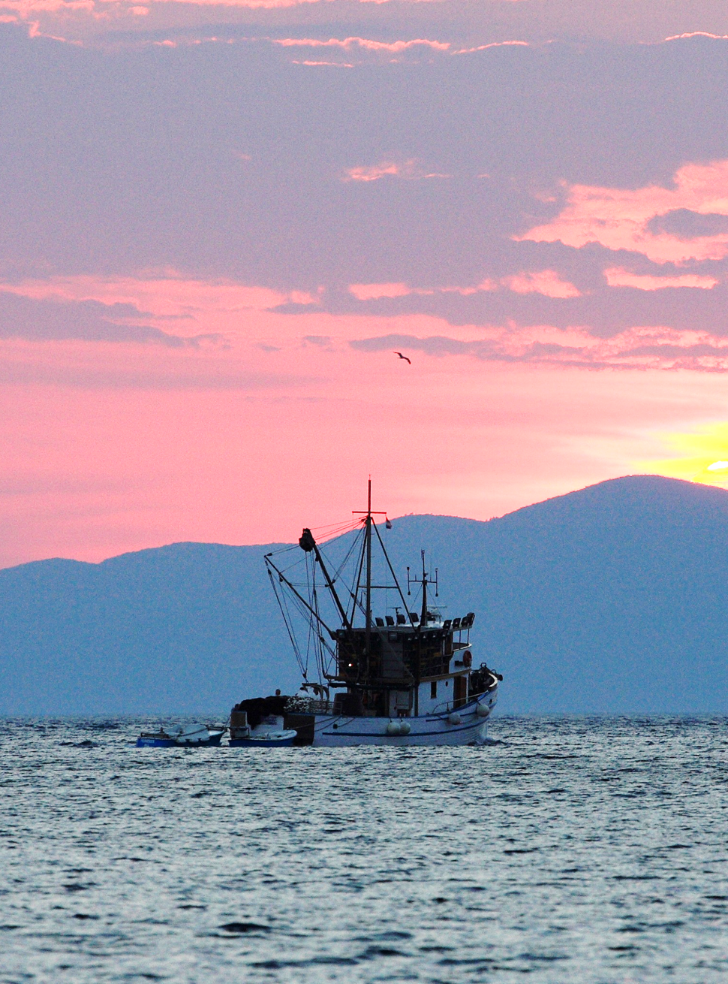

Median annual wages for Washington State are $47,733 for sailors and marine oilers, $75,408 for captains, mates and pilots of commercial vessels, $81,362 for ship engineers, and $91,216 for marine engineers and naval architects. Source: Washington State Employment Security Department, 2014
Source: Washington State Maritime Cluster Economic Impact Study, 2013 Charts – Source: Bureau of Labor Statistics (2013), Washington State Employment Security Department (2013), U.S. Department of Labor Bureau of Labor Statistics, U.S. Census (2013). Includes covered private and public jobs, and sole proprietors.
Source: Washington State Maritime Cluster Economic Impact Study, 2013
This section adapted from MapYourCareer.org (www.mapyourcareer.org/maritime/life-at-sea.html)
For a couple of interviews, see “Stories from the Field” at http://www.mapyourcareer.org/maritime/stories-from-the-field.html
This definition is adapted from http://www.marad.dot.gov/mariners_landing_page/mariner_landing_page.htm
This section adapted from the U.S. Bureau of Labor Statistics Occupational Outlook Handbook – Water Transportation Occupations (http://www.bls.gov/ooh/transportation-and-material-moving/water-transportation-occupations.htm#tab-2)
Charts – Source: U.S. Bureau of Labor Statistics and Washington State Employment Security Department
This section adapted from MapYourCareer.org (http://www.mapyourcareer.org/maritime/training-education.html)
Source: http://workboatacademy.com/Articles/Industry_Opportunities.pdf
See http://www.uscg.mil/nmc/professional_qualifications/default.asp
This section adapted from MapYourCareer.org (http://www.mapyourcareer.org/maritime/career-path.html)
This section is adapted from the Alaska Maritime Workforce Development Plan and “Fishy business,” by Stephen H. Dunphy. See http://crosscut.com/2013/09/commercial-fishing-business-seattle/ for more.
This section is adapted from http://www.alaskafishingjobsnetwork.com/overview/seafood-havesting-and-processing/
This section is adapted from http://jobs.alaska.gov/seafood/processing.html
"U.S. Port Ranking By Cargo Volume". American Association of Port Authorities. 2012.
Source: San Jacinto Community College
See the page http://www.sname.org/educationoptions/careersinthemaritimeindustry for a full listing.

